|  |  |  |  |  |  |  |
| --- | --- | --- | --- | --- | --- | --- |
| |  |  |  |  | | --- | --- | --- | --- | |  | | **MINISTRY OF EDUCATION AND TRAINING** | | | **FPT UNIVERSITY** | | |
| Capstone Project Document |
| Online Medical Consultant System |
| |  |  |  |  |  |  |  |  |  |  |  | | --- | --- | --- | --- | --- | --- | --- | --- | --- | --- | --- | | |  |  | | --- | --- | | **Group 02 – Report 04** | | | **Group member** | Trần Nguyên Tiến Sứ - Team Leader - SE60781  Trần Cao Danh - Team Member - SE60705 | | **Supervisor** | Mr. Nguyễn Huy Hùng | | **Ext. Supervisor** | N/A | | **Capstone Project code** | OMCS | | |
| * Ho Chi Minh City, 20 June / 2014 – |

Table of Contents

List of Tables 3

No table of figures entries found.List of Figures 3

Definitions, Acronyms, and Abbreviations 4

A. Report No.4: Software Design Description (SDD) 5

1. Design Overview 5

2. System Architectural Design 6

2.1 Choice of system architecture 6

2.2 Description of System Interface 6

3. Component Diagram 7

4. Detailed Description of Components 8

4.1 Class Diagram 8

5. Sequence Diagram 9

5.1 <Guest> Login 9

5.2 <Guest> Register 9

5.3 <Authorized User> Change Password 10

5.4 <Authorized User> Change Profile Picture 11

5.5 <Patient> Conversation 12

5.6 <Doctor> Request Webcam 13

5.7 <Patient> Upload Attachment 13

5.8 <Admin> Define New Medical Profile Template 14

5.9 <Admin> Update Medical Profile Template 15

5.10 <Doctor> Update Medical Profile 16

5.11 <Doctor> Views Medical Profile 17

5.12 <Patient> Update Personal Health Record 17

5.13 <Patient> View Medical Profile 18

6. User Interface Design 18

7. Database Design 18

# List of Tables

# No table of figures entries found.List of Figures

Figure 1: MVC Architecture 6

Figure 2: Component Diagram 7

Figure 3: Class Diagram 8

Figure 4: <Guest> Login Sequence Diagram 9

Figure 5: <Guest> Register Sequence Diagram 10

Figure 6: <Authorized User> Change Password Sequence Diagram 11

Figure 7: <Authorized User> Change Profile Picture Sequence Diagram 11

Figure 8: <Patient> Conversation Sequence Diagram 12

Figure 9: <Doctor> Request Webcam Sequence Diagram 13

Figure 10: <Patient> Upload Attachment 13

Figure 11 <Admin> Define New Medical Profile Template 14

Figure 12 <Admin> Update Medical Profile Template 15

Figure 13: <Doctor> Update Medical Profile 16

Figure 14: <Doctor> Views Medical Profile 17

Figure 15: <Patient> Update Personal Health Record 17

# Definitions, Acronyms, and Abbreviations

# 

# Report No.4: Software Design Description (SDD)

## Design Overview

* This document describes the technical and user interface design of. It includes the architectural design, the detailed design of common functions and business functions and the design of database model.
* The architectural design describes the overall architecture of the system and the architecture of each main component.
* The detailed design describes static and dynamic structure for each component and functions. It includes class diagrams, class explanations and sequence diagrams for each use cases.
* The database design describes the relationships between entities and details of each entity.

## System Architectural Design

### Choice of system architecture



Figure : MVC Architecture

**(http://smist08.wordpress.com/tag/mvc/)**

**The Model** is the part of the application that handles the logic for the application data.  
Often model objects retrieve data (and store data) from a database.

**The View** is the parts of the application that handles the display of the data.  
Most often the views are created from the model data.

**The Controller** is the part of the application that handles user interaction.  
Typically controllers read data from a view, control user input, and send input data to the model.

**(**<http://www.w3schools.com/aspnet/mvc_intro.asp>**)**

### Description of System Interface

#### User interfaces

* Web-based user interfaces that rely on Bootstrap. Focusing on user experience

#### Hardware interfaces

* The OMCS is intended as a website runs well on all modern web browsers. The website should be deployed online and accessible on any computer using different Operation Systems. At present, OMCS does not have mobile version.

#### Software interfaces

* The system should be able to run on any browser supported HTML 5.
* Any service exposed by the system should be accessible using HTTP protocol.

#### Communication interfaces

* The system uses HTTP protocol to communicate between server and clients.

## Component Diagram



Figure 2: Component Diagram

## Detailed Description of Components

### Class Diagram

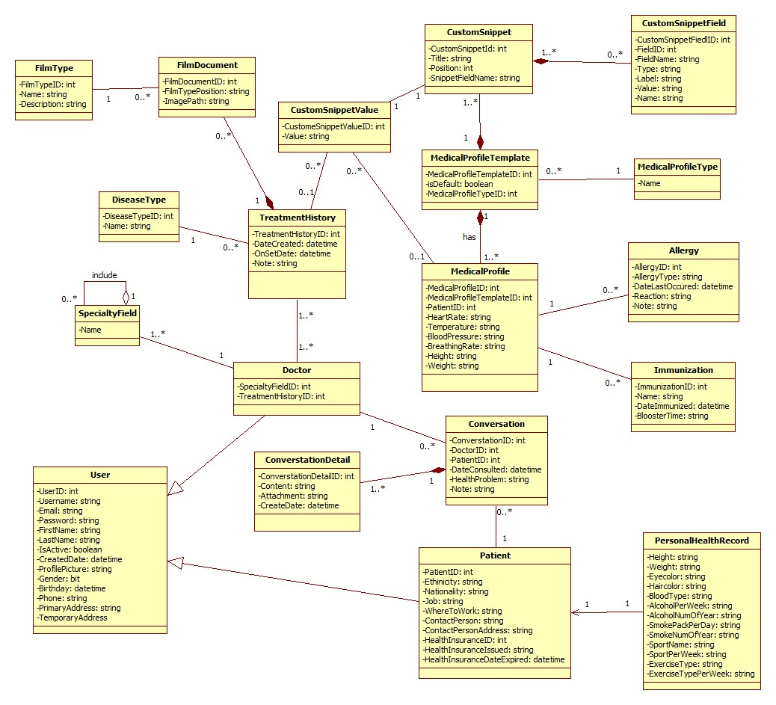

Figure 3: Class Diagram

## Sequence Diagram

### <Guest> Login



Figure 4: <Guest> Login Sequence Diagram

### <Guest> Register



Figure 5: <Guest> Register Sequence Diagram

### <Authorized User> Change Password



Figure 6: <Authorized User> Change Password Sequence Diagram

### <Authorized User> Change Profile Picture



Figure 7: <Authorized User> Change Profile Picture Sequence Diagram

### <Patient> Conversation



Figure : <Patient> Conversation Sequence Diagram

### <Doctor> Request Webcam



Figure 9: <Doctor> Request Webcam Sequence Diagram

### <Patient> Upload Attachment



Figure 10: <Patient> Upload Attachment

### <Admin> Define New Medical Profile Template



Figure <Admin> Define New Medical Profile Template

### <Admin> Update Medical Profile Template



Figure <Admin> Update Medical Profile Template

### <Doctor> Update Medical Profile

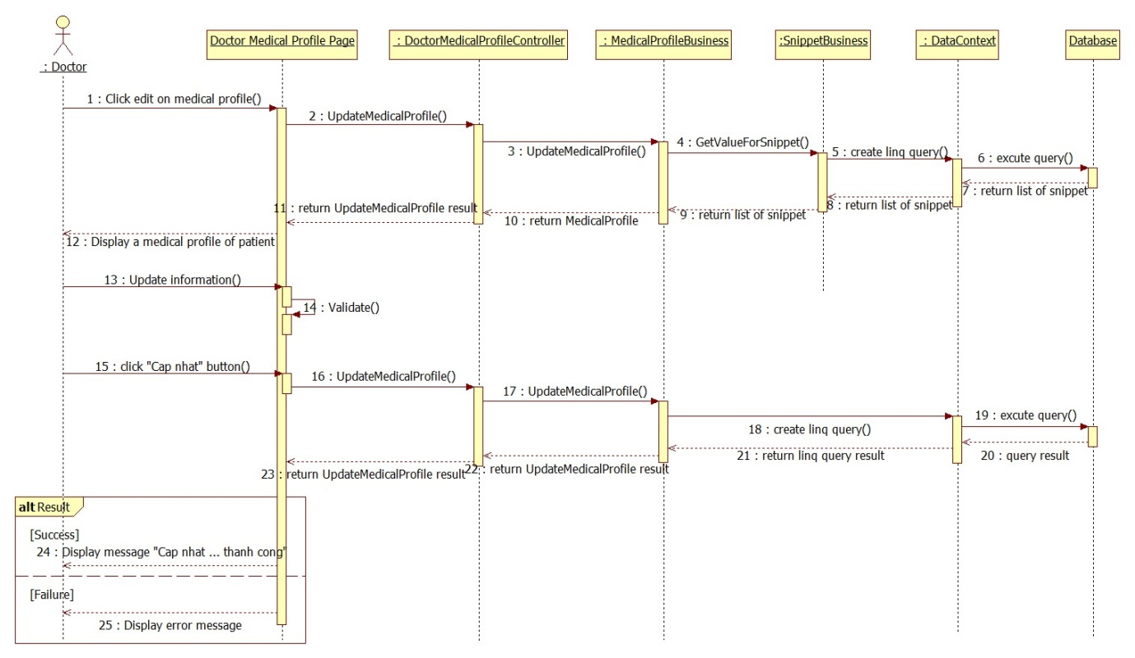

Figure : <Doctor> Update Medical Profile

### <Doctor> Views Medical Profile



Figure 14: <Doctor> Views Medical Profile

### <Patient> Update Personal Health Record



Figure : <Patient> Update Personal Health Record

### <Patient> View Medical Profile



Figure 9: <Patient> View Medical Profile Record

## User Interface Design

### HOMEPAGE SCREEN

#### Screen Images

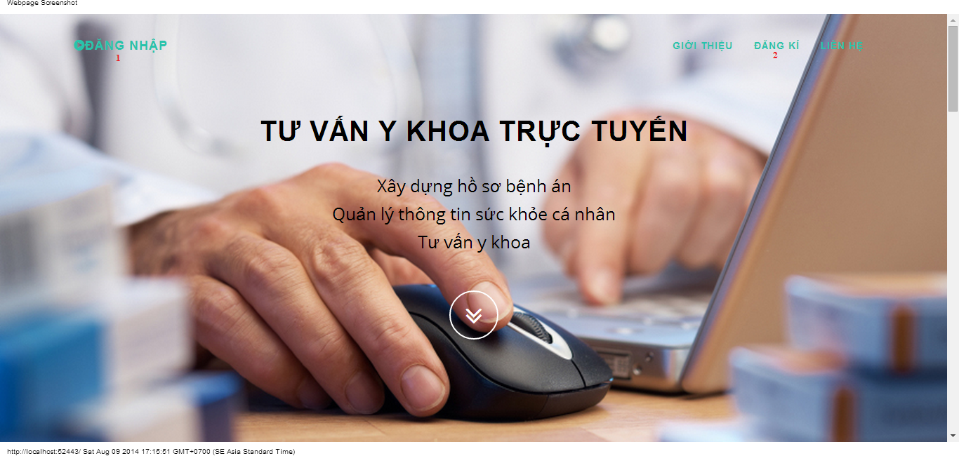

#### Objects and Actions

#### Data fields

|  |  |  |  |  |  |  |
| --- | --- | --- | --- | --- | --- | --- |
| **Field No** | **Field name** | **Type** | **Mandatory** | **Data type** | **Max length** | **Description** |

#### Actions

|  |  |  |  |  |  |
| --- | --- | --- | --- | --- | --- |
| **Field No** | **Field name** | **Type** | **Action** | **Description** | **Validation** |
| 1 | Đăng nhập | Link | On click | Forward to “Login” page |  |
| 2 | Đăng kí | Link | On click | Forward to “Register” page |  |

### LOGIN SCREEN

#### Screen image

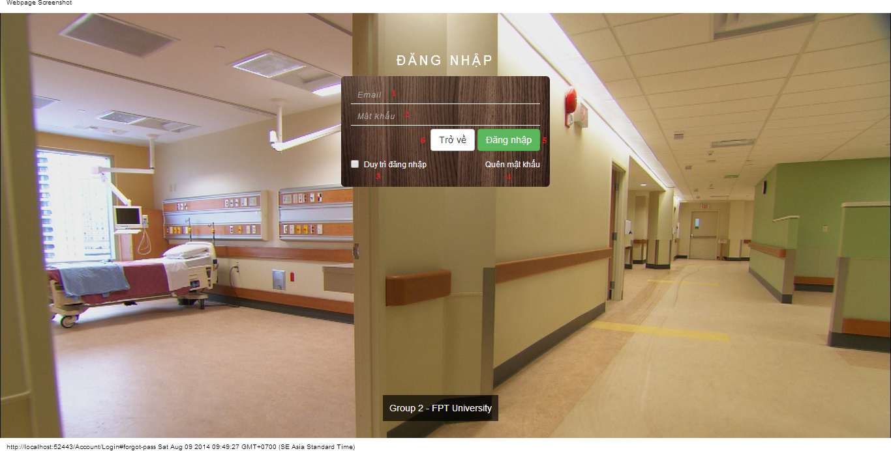

#### Objects and Actions

#### Data fields

|  |  |  |  |  |  |  |
| --- | --- | --- | --- | --- | --- | --- |
| **Field No** | **Field name** | **Type** | **Mandatory** | **Data type** | **Max length** | **Description** |
| 1 | Email | Textbox | Yes | String |  | Contain user’s email to login |
| 2 | Mật khẩu | Textbox | Yes | String |  | Contain user’s password to login |
| 3 | Duy trì đăng nhập | Checkbox | No | Boolean |  | Check to remember user to login again |

#### Actions

|  |  |  |  |  |  |
| --- | --- | --- | --- | --- | --- |
| **Field No** | **Field name** | **Type** | **Action** | **Description** | **Validation** |
| 4 | Quên mật khẩu | Link | On click | Forward to popup “ForgotPassword”. |  |
| 5 | Đăng nhập | Button | On click | Forward to page follow user’s role. | Email and password not empty |
| 6 | Trở về | Button | On click | Cancel the login. Back to previous page. |  |

### REGISTER SCREEN

#### Screen image

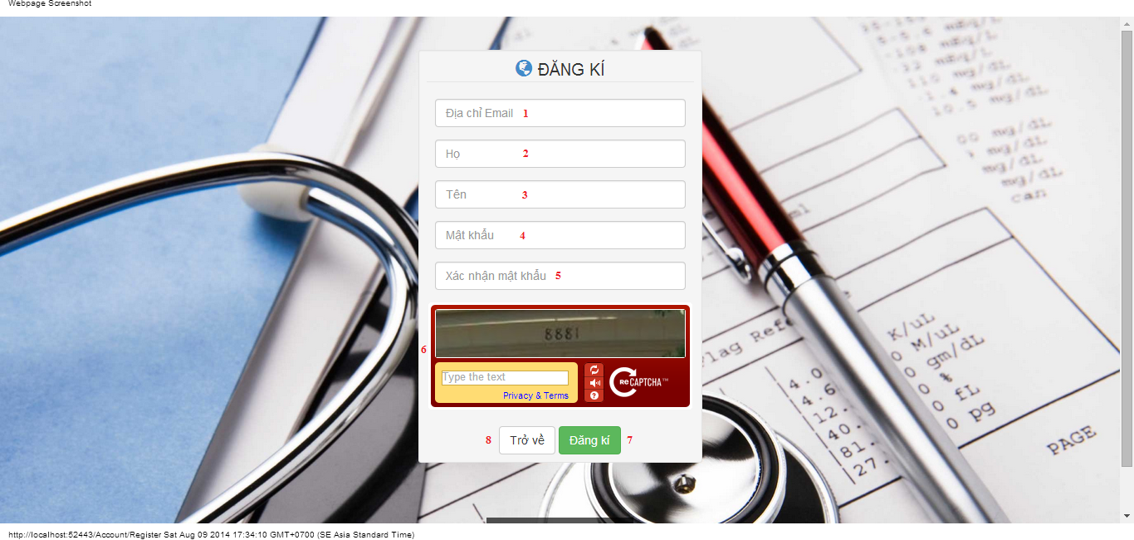

#### Objects and Actions

#### Data fields

|  |  |  |  |  |  |  |
| --- | --- | --- | --- | --- | --- | --- |
| **Field No** | **Field name** | **Type** | **Mandatory** | **Data type** | **Max length** | **Description** |
| 1 | Địa chỉ Email | Textbox | Yes | String | 50 | Contain user’s email to login |
| 2 | Họ | Textbox | Yes | String | 25 | Contain user’s last name |
| 3 | Tên | Textbox | Yes | String | 25 | Contain user’s first name |
| 4 | Mật khẩu | Textbox | Yes | String | 25 | Contain user’s password to login |
| 5 | Xác nhận mật khẩu | Textbox | Yes | String | 25 | Contain the confirm password |
| 6 | Retype Image | Textbox | Yes | String |  | Contain the verifying captcha |

#### Actions

|  |  |  |  |  |  |
| --- | --- | --- | --- | --- | --- |
| **Field No** | **Field name** | **Type** | **Action** | **Description** | **Validation** |
| 7 | Đăng kí | Button | On click | Submit inputted data to server | Inputted data must be valid |
| 8 | Trở về | Button | On click | Cancel the registration. Back to previous page |  |

### FORGOT PASSWORD SCREEN

#### Screen image

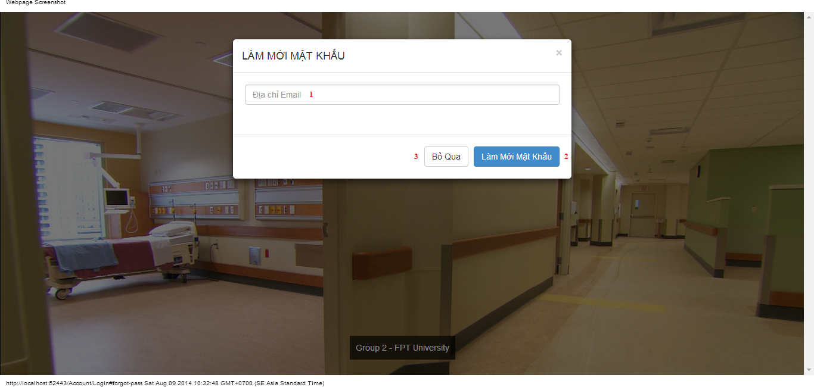

#### Objects and Actions

#### Data fields

|  |  |  |  |  |  |  |
| --- | --- | --- | --- | --- | --- | --- |
| **Field No** | **Field name** | **Type** | **Mandatory** | **Data type** | **Max length** | **Description** |
| 1 | Địa chỉ Email | Textbox | Yes | String |  | Contain user’s email to reset password |

#### Actions

|  |  |  |  |  |  |
| --- | --- | --- | --- | --- | --- |
| **Field No** | **Field name** | **Type** | **Action** | **Description** | **Validation** |
| 2 | Làm mới mật khẩu | Button | On click | Submit inputted data to server | Inputted data must be valid |
| 3 | Bỏ qua | Button | On click | Dismiss model. Back to login page |  |

### ADMIN HOSPITAL INFORMATION SCREEN

#### Screen image

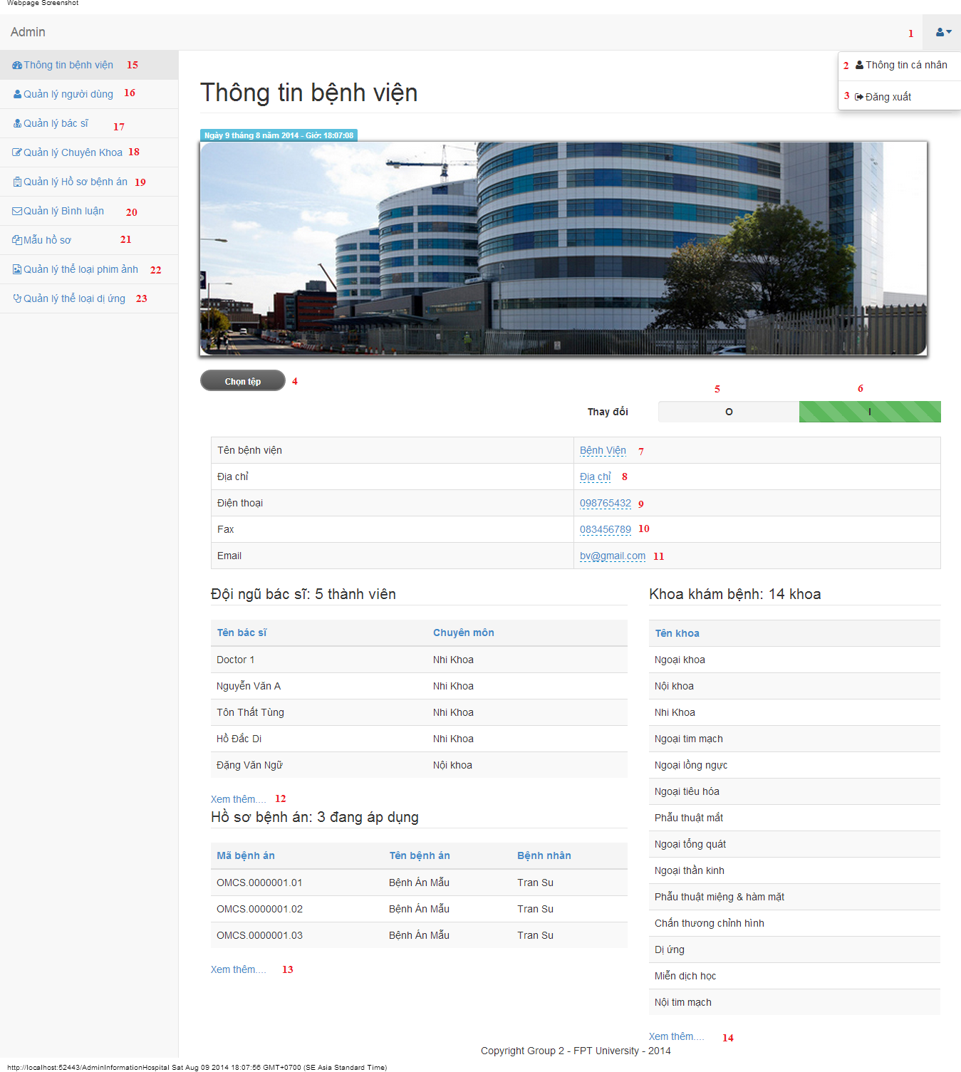

#### Objects and Actions

#### Data fields

|  |  |  |  |  |  |  |
| --- | --- | --- | --- | --- | --- | --- |
| **Field No** | **Field name** | **Type** | **Mandatory** | **Data type** | **Max length** | **Description** |
| 7 | Tên bệnh viện | Textbox | Yes | String | 50 | Contain hospital’s name |
| 8 | Địa chỉ | Textbox | Yes | String | 50 | Contain hospital’s address |
| 9 | Điện thoại | Textbox | Yes | String | 12 | Contain hospital’s phone |
| 10 | Fax | Textbox | Yes | String | 12 | Contain hospital’s fax |
| 11 | Email | Textbox | Yes | String | 50 | Contain hospital’s email |

#### Actions

|  |  |  |  |  |  |
| --- | --- | --- | --- | --- | --- |
| **Field No** | **Field name** | **Type** | **Action** | **Description** | **Validation** |
| 1 |  | DDL | On click | List “Thông tin cá nhân” and “Đăng xuất” |  |
| 2 | Thông tin cá nhân | Link | On click | Forward to “AdminInformation” page |  |
| 3 | Đăng xuất | Link | On click | Back to login page |  |
| 4 | Chọn tệp | File | On click | Submit inputted file to server |  |
| 5 | 0 | Checkbox | On click | Click “0” to view table hospital information |  |
| 6 | I | Checkbox | On click | Click “I” to edit table data hospital information |  |
| 12 | Xem thêm… | Link | On click | Forward to “AdminDoctor” page |  |
| 13 | Xem thêm… | Link | On click | Forward to “AdminMedicalProfile” page |  |
| 14 | Xem thêm… | Link | On click | Forward to “AdminSpecialtyField” page |  |
| 15 | Thông tin bệnh viện | Link | On click | Forward to “AdminInformationHospital” page |  |
| 16 | Quản lý người dùng | Link | On click | Forward to “AdminUser” page |  |
| 17 | Quản lý bác sĩ | Link | On click | Forward to “AdminDoctor” page |  |
| 18 | Quản lý chuyên khoa | Link | On click | Forward to “AdminSpecialtyField” page |  |
| 19 | Quản lý hồ sơ bệnh án | Link | On click | Forward to “AdminMedicalProfile” page |  |
| 20 | Quản lý bình luận | Link | On click | Forward to “AdminComment” page |  |
| 21 | Mẫu hồ sơ | Link | On click | Forward to “AdminTemplate” page |  |
| 22 | Quản lý thể loại phim ảnh | Link | On click | Forward to “FilmType” page |  |
| 23 | Quản lý thể loại dị ứng | Link | On click | Forward to “AllergyType” page |  |

### ADMIN INFORMATION SCREEN

#### Screen image

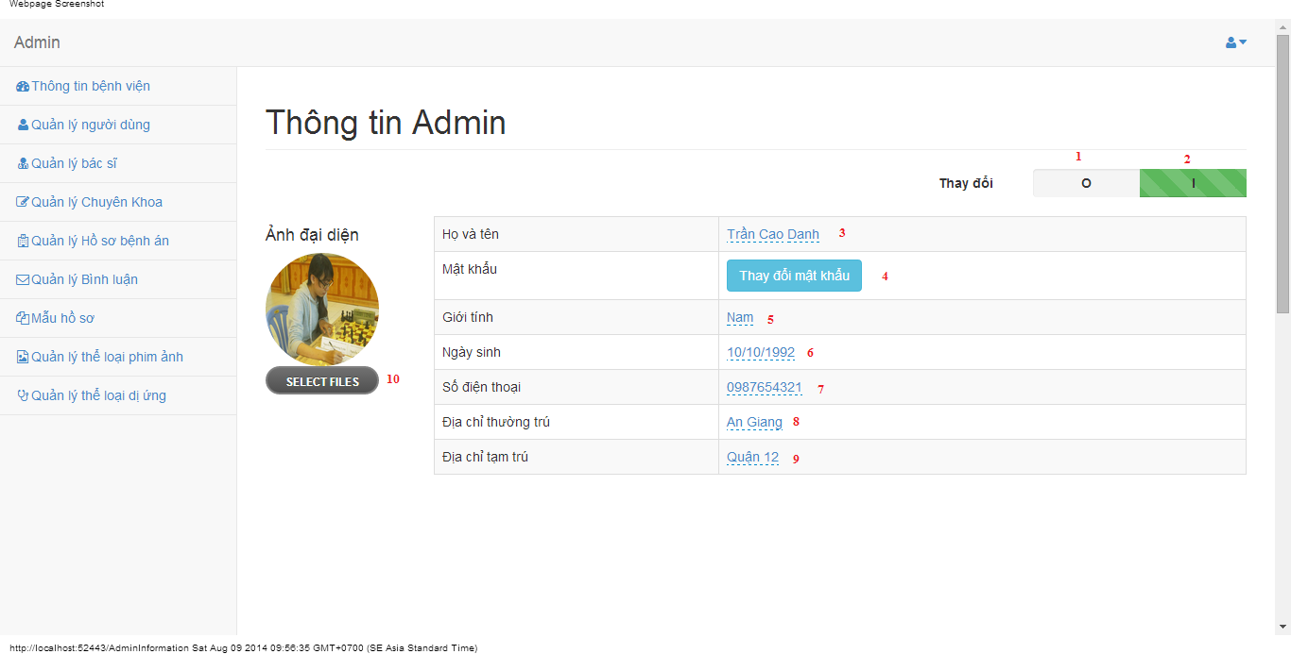

#### Objects and Actions

#### Data fields

|  |  |  |  |  |  |  |
| --- | --- | --- | --- | --- | --- | --- |
| **Field No** | **Field name** | **Type** | **Mandatory** | **Data type** | **Max length** | **Description** |
| 3 | Họ và tên | Textbox | Yes | String | 50 | Contain user’s full name |
| 5 | Giới tính | List | Yes | String | 50 | Contain user’s gender |
| 6 | Ngày sinh | Textbox | Yes | Date | 12 | Contain user’s birthday |
| 7 | Số điện thoại | Textbox | Yes | String | 12 | Contain user’s phone |
| 8 | Địa chỉ thường trú | Textbox | Yes | String | 50 | Contain user’s primary address |
| 9 | Địa chỉ tạm trú | Textbox | No | String | 50 | Contain user’s secondary address |

#### Actions

|  |  |  |  |  |  |
| --- | --- | --- | --- | --- | --- |
| **Field No** | **Field name** | **Type** | **Action** | **Description** | **Validation** |
| 1 | 0 | Checkbox | On click | Click “0” to view table admin information |  |
| 2 | I | Checkbox | On click | Click “I” to edit table data admin information |  |
| 4 | Thay đổi mật khẩu | Button | On click | Forward to popup “ChangePassword” |  |
| 10 | Chọn tệp | File | On click | Submit inputted file to server |  |

### MANAGE USERS SCREEN

#### Screen image

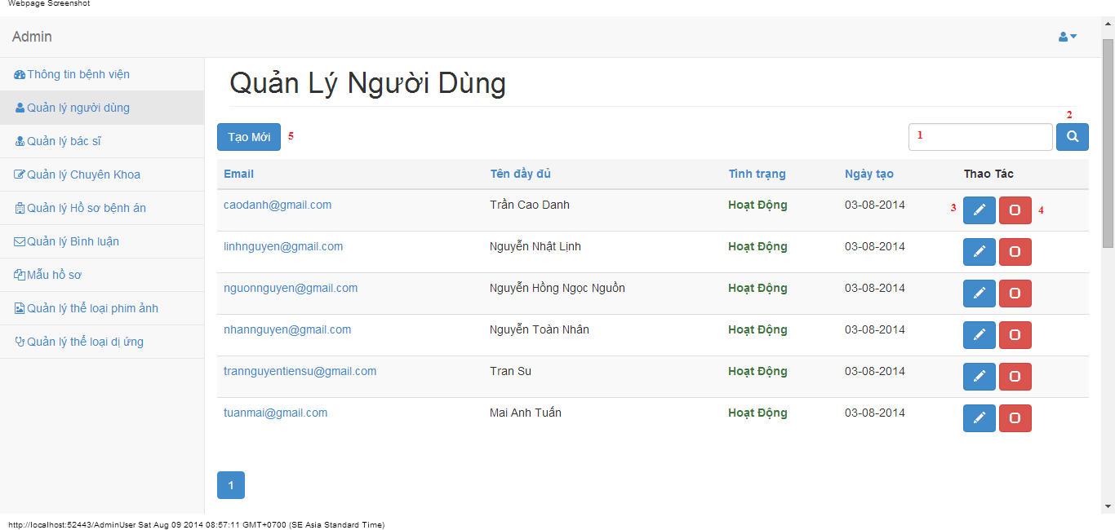

#### Objects and Actions

#### Data fields

|  |  |  |  |  |  |  |
| --- | --- | --- | --- | --- | --- | --- |
| **Field No** | **Field name** | **Type** | **Mandatory** | **Data type** | **Max length** | **Description** |
| 1 | Search | Textbox | No | String | 50 | Contain search condition to find some user account |

#### Actions

|  |  |  |  |  |  |
| --- | --- | --- | --- | --- | --- |
| **Field No** | **Field name** | **Type** | **Action** | **Description** | **Validation** |
| 2 | Tìm | Button | On click | Send inputted search condition to server |  |
| 3 | Cập nhật | Button | On click | Forward to popup “Edit” |  |
| 4 | Vô hiệu/Kích hoạt | Link | On click | Deactivate user or Activate user |  |
| 5 | Tạo mới | Button | On click | Forward to popup “Create” |  |

### CREATE USER SCREEN

#### Screen image

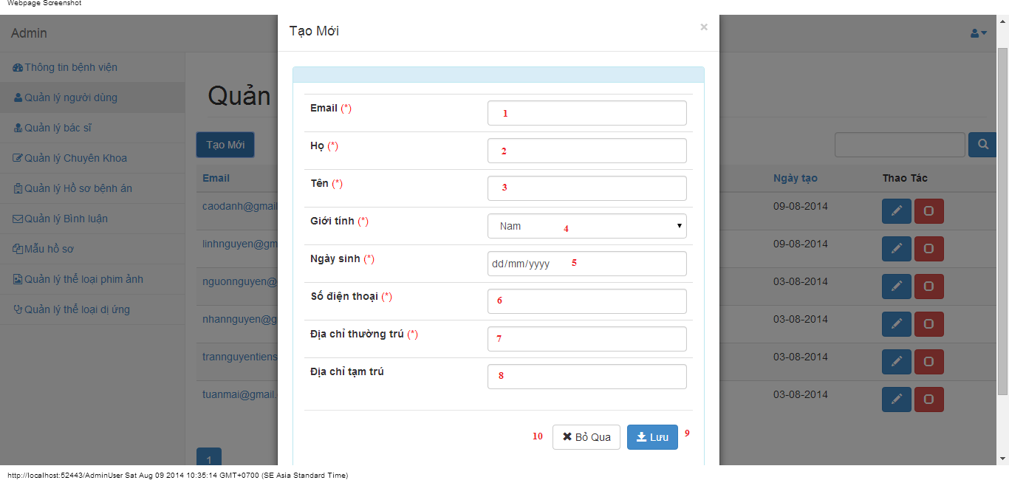

#### Objects and Actions

#### Data fields

|  |  |  |  |  |  |  |
| --- | --- | --- | --- | --- | --- | --- |
| **Field No** | **Field name** | **Type** | **Mandatory** | **Data type** | **Max length** | **Description** |
| 1 | Email | Textbox | Yes | String | 50 | Contain user’s email |
| 2 | Họ | Textbox | Yes | String | 50 | Contain user’s last name |
| 3 | Tên | Textbox | Yes | String | 50 | Contain user’s first name |
| 4 | Giới tính | Textbox | Yes | String |  | Contain user’s gender |
| 5 | Ngày sinh | Textbox | Yes | Date |  | Contain user’s birthday |
| 6 | Số điện thoại | Textbox | Yes | String | 12 | Contain user’s phone |
| 7 | Địa chỉ thường trú | Textbox | Yes | String | 50 | Contain user’s primary address |
| 8 | Địa chỉ tạm trú | Textbox | No | String | 50 | Contain user’s secondary address |

#### Actions

|  |  |  |  |  |  |
| --- | --- | --- | --- | --- | --- |
| **Field No** | **Field name** | **Type** | **Action** | **Description** | **Validation** |
| 9 | Lưu | Button | On click | Submit inputted data to server | Inputted data must be valid |
| 10 | Bỏ qua | Button | On click | Dismiss popup |  |

### EDIT USER SCREEN

#### Screen image

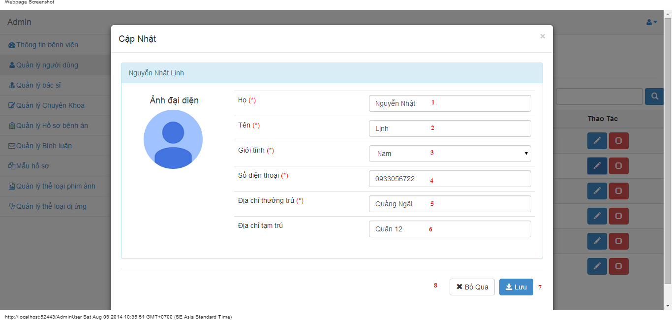

#### Objects and Actions

#### Data fields

|  |  |  |  |  |  |  |
| --- | --- | --- | --- | --- | --- | --- |
| **Field No** | **Field name** | **Type** | **Mandatory** | **Data type** | **Max length** | **Description** |
| 1 | Họ | Textbox | Yes | String | 50 | Contain user’s last name |
| 2 | Tên | Textbox | Yes | String | 50 | Contain user’s first name |
| 3 | Giới tính | Textbox | Yes | String |  | Contain user’s gender |
| 4 | Số điện thoại | Textbox | Yes | String | 12 | Contain user’s phone |
| 5 | Địa chỉ thường trú | Textbox | Yes | String | 50 | Contain user’s primary address |
| 6 | Địa chỉ tạm trú | Textbox | No | String | 50 | Contain user’s secondary address |

#### Actions

|  |  |  |  |  |  |
| --- | --- | --- | --- | --- | --- |
| **Field No** | **Field name** | **Type** | **Action** | **Description** | **Validation** |
| 7 | Lưu | Button | On click | Submit inputted data to server | Inputted data must be valid |
| 8 | Bỏ qua | Button | On click | Dismiss popup |  |

### MANAGE DOCTORS SCREEN

#### Screen image

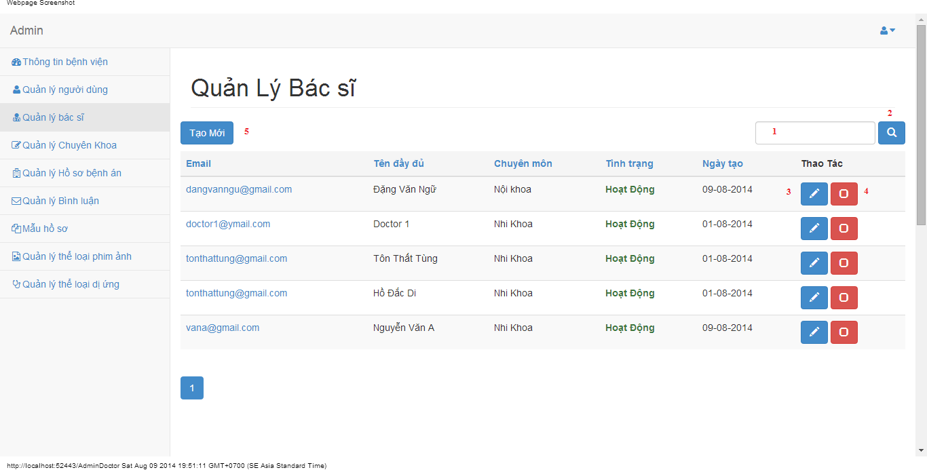

#### Objects and Actions

#### Data fields

|  |  |  |  |  |  |  |
| --- | --- | --- | --- | --- | --- | --- |
| **Field No** | **Field name** | **Type** | **Mandatory** | **Data type** | **Max length** | **Description** |
| 1 | Search | Textbox | No | String | 50 | Contain search condition to find some user account |

#### Actions

|  |  |  |  |  |  |
| --- | --- | --- | --- | --- | --- |
| **Field No** | **Field name** | **Type** | **Action** | **Description** | **Validation** |
| 2 | Tìm | Button | On click | Send inputted search condition to server |  |
| 3 | Cập nhật | Button | On click | Forward to popup “Edit” |  |
| 4 | Vô hiệu/Kích hoạt | Link | On click | Deactivate user or Activate user |  |
| 5 | Tạo mới | Button | On click | Forward to popup “Create” |  |

### CREATE DOCTOR SCREEN

#### Screen image

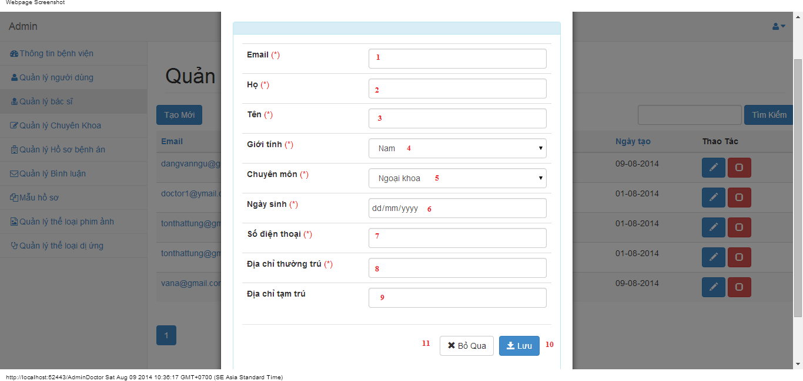

#### Objects and Actions

#### Data fields

|  |  |  |  |  |  |  |
| --- | --- | --- | --- | --- | --- | --- |
| **Field No** | **Field name** | **Type** | **Mandatory** | **Data type** | **Max length** | **Description** |
| 1 | Email | Textbox | Yes | String | 50 | Contain user’s email |
| 2 | Họ | Textbox | Yes | String | 50 | Contain user’s last name |
| 3 | Tên | Textbox | Yes | String | 50 | Contain user’s first name |
| 4 | Giới tính | Textbox | Yes | String |  | Contain user’s gender |
| 5 | Chuyên môn | DDL | Yes | String |  | Contain user’s specialty field |
| 6 | Ngày sinh | Textbox | Yes | Date |  | Contain user’s birthday |
| 7 | Số điện thoại | Textbox | Yes | String | 12 | Contain user’s phone |
| 8 | Địa chỉ thường trú | Textbox | Yes | String | 50 | Contain user’s primary address |
| 9 | Địa chỉ tạm trú | Textbox | No | String | 50 | Contain user’s secondary address |

#### Actions

|  |  |  |  |  |  |
| --- | --- | --- | --- | --- | --- |
| **Field No** | **Field name** | **Type** | **Action** | **Description** | **Validation** |
| 9 | Lưu | Button | On click | Submit inputted data to server |  |
| 10 | Bỏ qua | Button | On click | Dismiss popup |  |

### EDIT DOCTOR SCREEN

#### Screen image

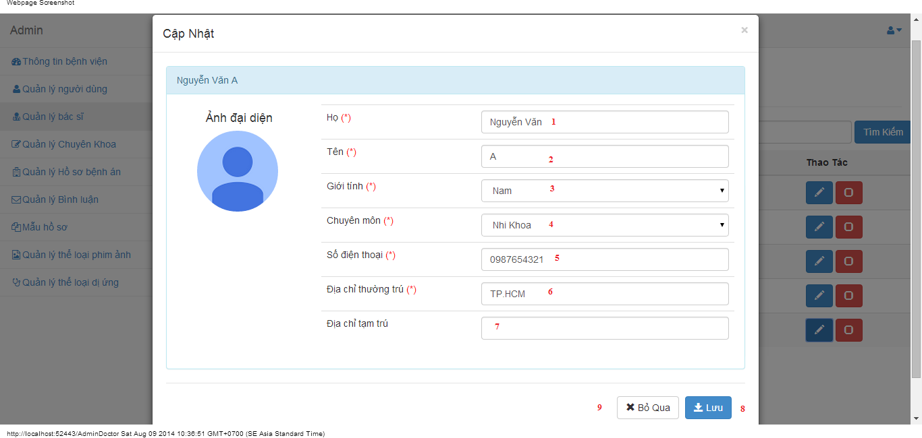

#### Objects and Actions

#### Data fields

|  |  |  |  |  |  |  |
| --- | --- | --- | --- | --- | --- | --- |
| **Field No** | **Field name** | **Type** | **Mandatory** | **Data type** | **Max length** | **Description** |
| 1 | Họ | Textbox | Yes | String | 50 | Contain user’s last name |
| 2 | Tên | Textbox | Yes | String | 50 | Contain user’s first name |
| 3 | Giới tính | Textbox | Yes | String |  | Contain user’s gender |
| 4 | Chuyên môn | DDL | Yes | String |  | Contain user’s specialty field |
| 5 | Số điện thoại | Textbox | Yes | String | 12 | Contain user’s phone |
| 6 | Địa chỉ thường trú | Textbox | Yes | String | 50 | Contain user’s primary address |
| 7 | Địa chỉ tạm trú | Textbox | No | String | 50 | Contain user’s secondary address |

#### Actions

|  |  |  |  |  |  |
| --- | --- | --- | --- | --- | --- |
| **Field No** | **Field name** | **Type** | **Action** | **Description** | **Validation** |
| 7 | Lưu | Button | On click | Submit inputted data to server | Inputted data must be valid |
| 8 | Bỏ qua | Button | On click | Dismiss popup |  |

### MANAGE SPECIALTY FIELDS SCREEN

#### Screen image

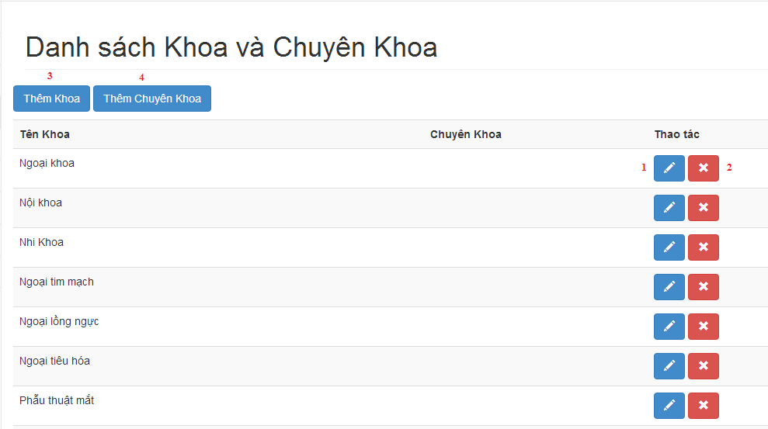

#### Objects and Actions

#### Data fields

|  |  |  |  |  |  |  |
| --- | --- | --- | --- | --- | --- | --- |
| **Field No** | **Field name** | **Type** | **Mandatory** | **Data type** | **Max length** | **Description** |

#### Actions

|  |  |  |  |  |  |
| --- | --- | --- | --- | --- | --- |
| **Field No** | **Field name** | **Type** | **Action** | **Description** | **Validation** |
| 1 | Cập nhật | Button | On click | Forward to popup “Edit” |  |
| 2 | Xóa | Button | On click | Delete a specialty field |  |
| 3 | Thêm khoa | Button | On click | Forward to popup “Create” |  |
| 4 | Thêm chuyên khoa | Button | On click | Forward to popup “Create” |  |

### CREATE SPECIALTY FIELD SCREEN

#### Screen image

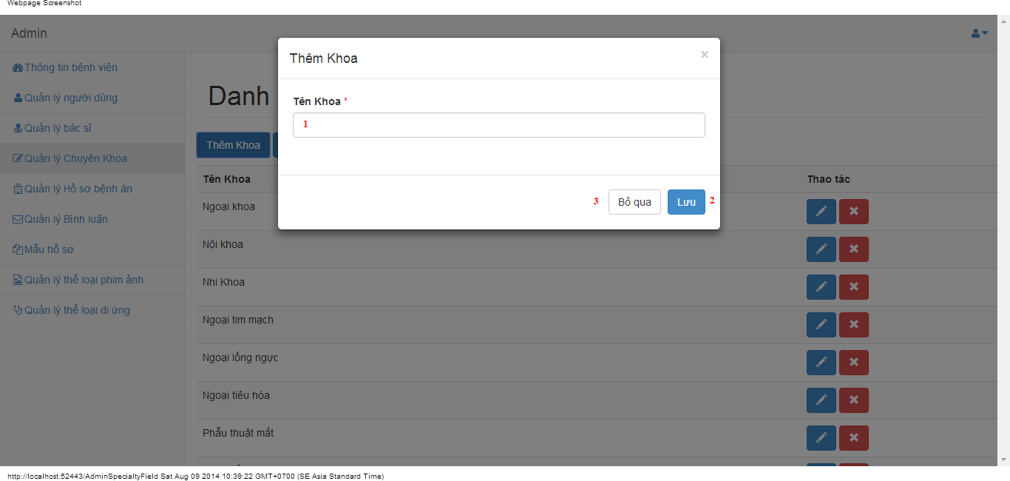

#### Objects and Actions

#### Data fields

|  |  |  |  |  |  |  |
| --- | --- | --- | --- | --- | --- | --- |
| **Field No** | **Field name** | **Type** | **Mandatory** | **Data type** | **Max length** | **Description** |
| 1 | Tên khoa | Textbox | Yes | String | 50 | Contain specialty field |

#### Actions

|  |  |  |  |  |  |
| --- | --- | --- | --- | --- | --- |
| **Field No** | **Field name** | **Type** | **Action** | **Description** | **Validation** |
| 9 | Lưu | Button | On click | Submit inputted data to server | Inputted data must be valid |
| 10 | Bỏ qua | Button | On click | Dismiss popup |  |

### CREATE SPECIALTY FIELD SCREEN

#### Screen image

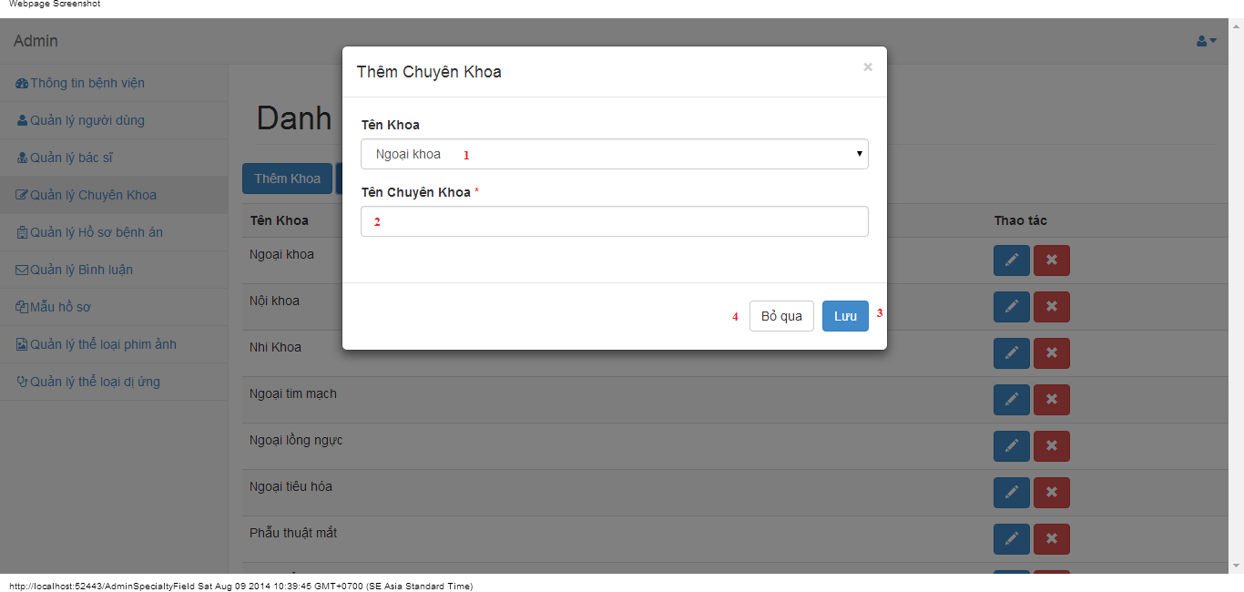

#### Objects and Actions

#### Data fields

|  |  |  |  |  |  |  |
| --- | --- | --- | --- | --- | --- | --- |
| **Field No** | **Field name** | **Type** | **Mandatory** | **Data type** | **Max length** | **Description** |
| 1 | Tên Khoa | DDL | Yes | String | 50 | Contain parent specialty fields |
| 2 | Tên Chuyên Khoa | Textbox | Yes | String | 50 | Contain specialty field |

#### Actions

|  |  |  |  |  |  |
| --- | --- | --- | --- | --- | --- |
| **Field No** | **Field name** | **Type** | **Action** | **Description** | **Validation** |
| 7 | Lưu | Button | On click | Submit inputted data to server | Inputted data must be valid |
| 8 | Bỏ qua | Button | On click | Dismiss popup |  |

### EDIT SPECIALTY FIELD SCREEN

#### Screen image

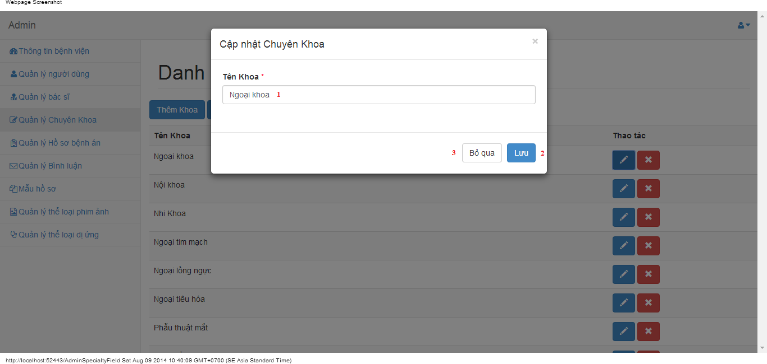

#### Objects and Actions

#### Data fields

|  |  |  |  |  |  |  |
| --- | --- | --- | --- | --- | --- | --- |
| **Field No** | **Field name** | **Type** | **Mandatory** | **Data type** | **Max length** | **Description** |
| 1 | Tên khoa | Textbox | Yes | String | 50 | Contain specialty field |

#### Actions

|  |  |  |  |  |  |
| --- | --- | --- | --- | --- | --- |
| **Field No** | **Field name** | **Type** | **Action** | **Description** | **Validation** |
| 9 | Lưu | Button | On click | Submit inputted data to server | Inputted data must be valid |
| 10 | Bỏ qua | Button | On click | Dismiss popup |  |

### EDIT SPECIALTY FIELD SCREEN

#### Screen image

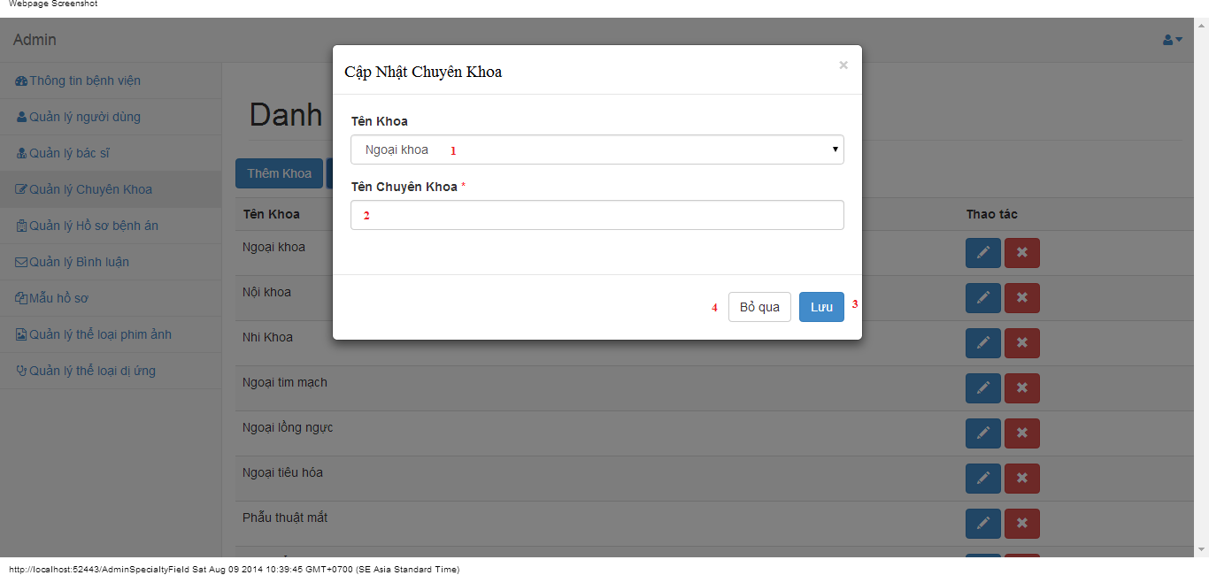

#### Objects and Actions

#### Data fields

|  |  |  |  |  |  |  |
| --- | --- | --- | --- | --- | --- | --- |
| **Field No** | **Field name** | **Type** | **Mandatory** | **Data type** | **Max length** | **Description** |
| 1 | Tên Khoa | DDL | Yes | String | 50 | Contain parent specialty fields |
| 2 | Tên Chuyên Khoa | Textbox | Yes | String | 50 | Contain specialty field |

#### Actions

|  |  |  |  |  |  |
| --- | --- | --- | --- | --- | --- |
| **Field No** | **Field name** | **Type** | **Action** | **Description** | **Validation** |
| 7 | Lưu | Button | On click | Submit inputted data to server | Inputted data must be valid |
| 8 | Bỏ qua | Button | On click | Dismiss popup |  |

### MANAGE MEDICAL PROFILES SCREEN

#### Screen image

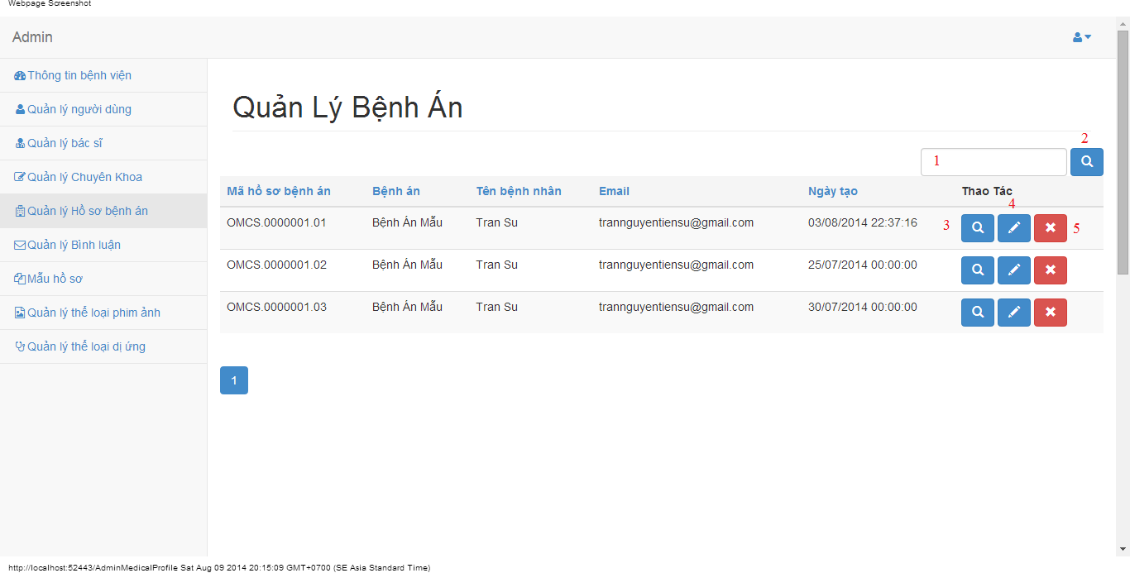

#### Objects and Actions

#### Data fields

|  |  |  |  |  |  |  |
| --- | --- | --- | --- | --- | --- | --- |
| **Field No** | **Field name** | **Type** | **Mandatory** | **Data type** | **Max length** | **Description** |
| 1 | Search | Textbox | No | String | 50 | Contain search condition to find some medical profile |

#### Actions

|  |  |  |  |  |  |
| --- | --- | --- | --- | --- | --- |
| **Field No** | **Field name** | **Type** | **Action** | **Description** | **Validation** |
| 2 | Tìm | Button | On click | Send inputted search condition to server |  |
| 3 | Xem chi tiết | Button | On click | Forward to “Details” page |  |
| 4 | Cập nhật | Link | On click | Forward to “UpdateMedicalProfile” page |  |
| 5 | Xóa | Button | On click | Delete a medical profile |  |

### VIEW MEDICAL PROFILE SCREEN

#### Screen image

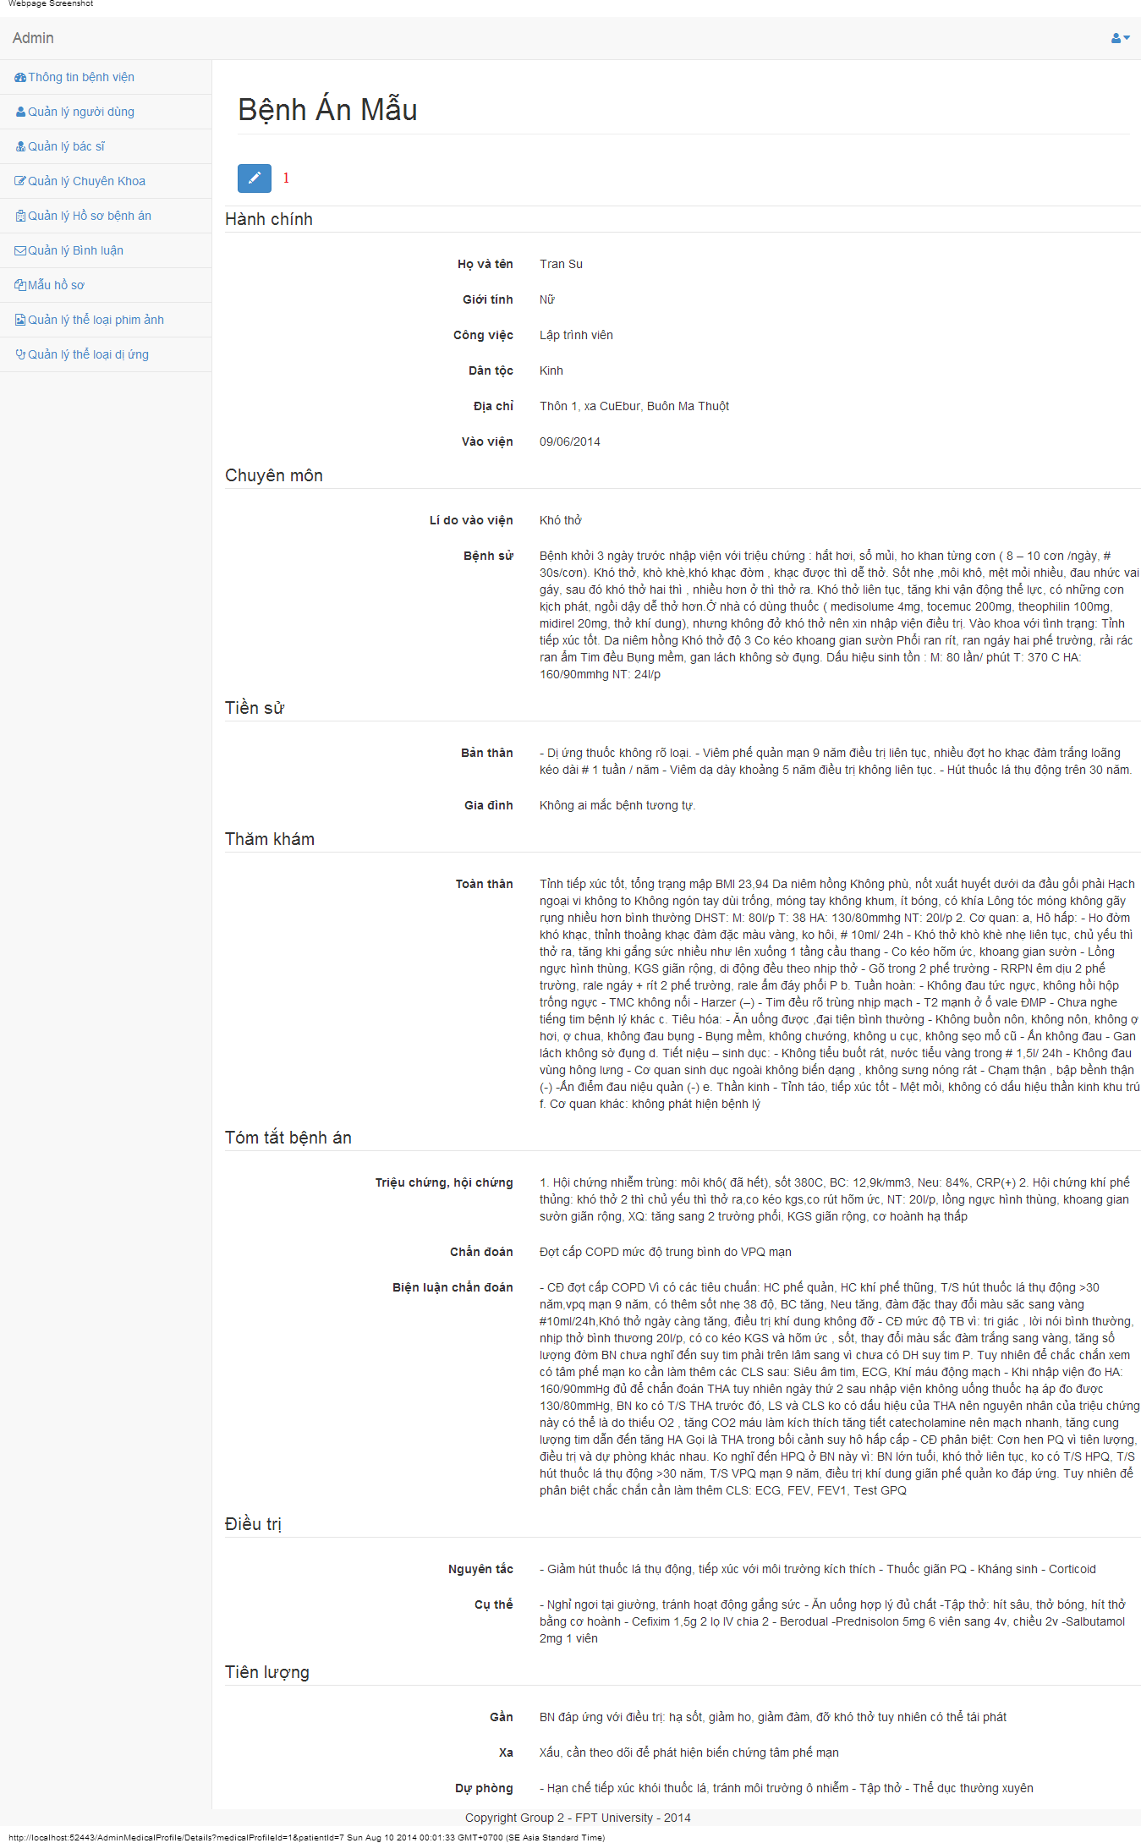

#### Objects and Actions

#### Data fields

|  |  |  |  |  |  |  |
| --- | --- | --- | --- | --- | --- | --- |
| **Field No** | **Field name** | **Type** | **Mandatory** | **Data type** | **Max length** | **Description** |

#### Actions

|  |  |  |  |  |  |
| --- | --- | --- | --- | --- | --- |
| **Field No** | **Field name** | **Type** | **Action** | **Description** | **Validation** |
| 1 | Cập nhật | Link | On click | Forward to “UpdateMedicalProfile” page |  |

### UPDATE MEDICAL PROFILE SCREEN

#### Screen image

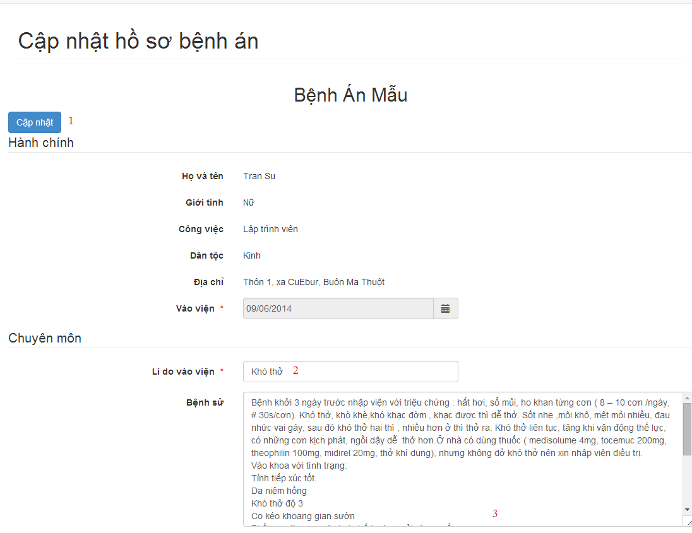

#### Objects and Actions

#### Data fields

|  |  |  |  |  |  |  |
| --- | --- | --- | --- | --- | --- | --- |
| **Field No** | **Field name** | **Type** | **Mandatory** | **Data type** | **Max length** | **Description** |
| 2 | Lí do vào viện | Textbox | Yes | String |  | Contain input follow medical profile template |
| 3 | Bệnh sử | Textbox | Yes | String |  | Contain input follow medical profile template |

#### Actions

|  |  |  |  |  |  |
| --- | --- | --- | --- | --- | --- |
| **Field No** | **Field name** | **Type** | **Action** | **Description** | **Validation** |
| 1 | Cập nhật | Link | On click | Submit inputted data to server |  |

### MANAGE MEDICAL PROFILES SCREEN

#### Screen image

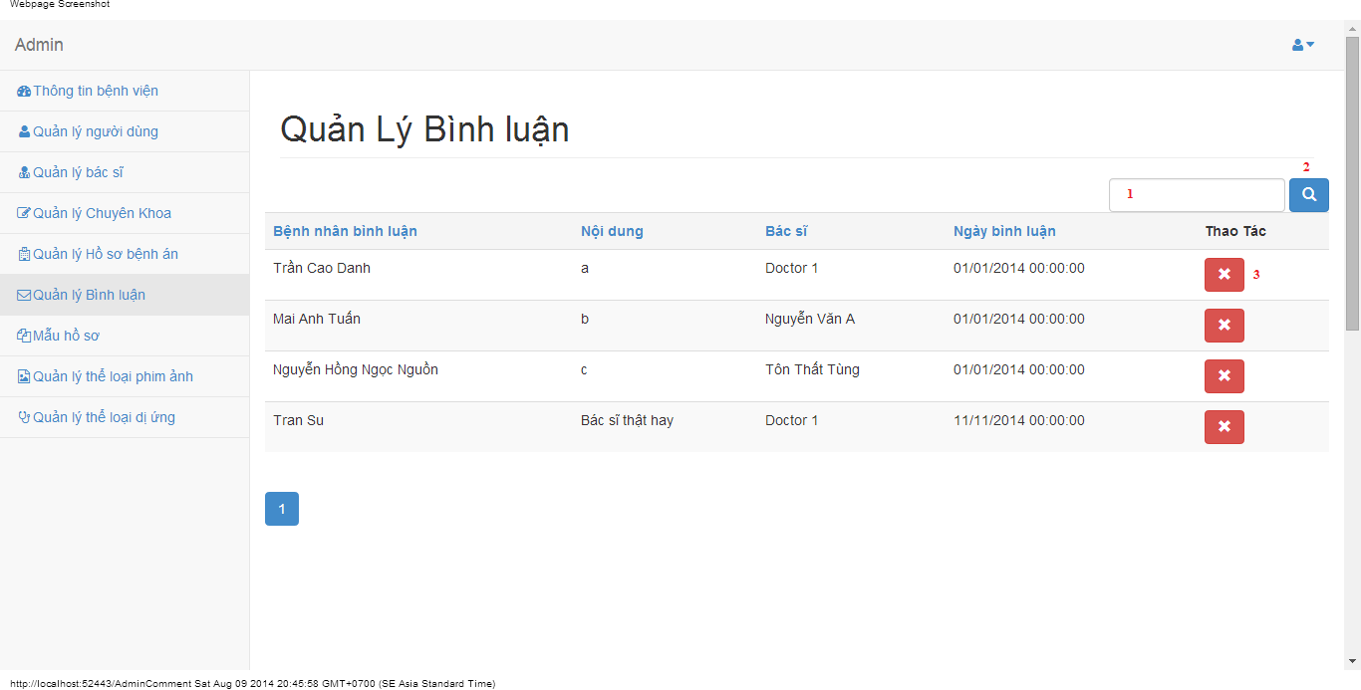

#### Objects and Actions

#### Data fields

|  |  |  |  |  |  |  |
| --- | --- | --- | --- | --- | --- | --- |
| **Field No** | **Field name** | **Type** | **Mandatory** | **Data type** | **Max length** | **Description** |
| 1 | Search | Textbox | No | String | 50 | Contain search condition to find some user account |

#### Actions

|  |  |  |  |  |  |
| --- | --- | --- | --- | --- | --- |
| **Field No** | **Field name** | **Type** | **Action** | **Description** | **Validation** |
| 2 | Tìm | Button | On click | Send inputted search condition to server |  |
| 3 | Xóa | Button | On click | Delete a comment |  |

### MANAGE MEDICAL PROFILE TEMPLATES SCREEN

#### Screen image

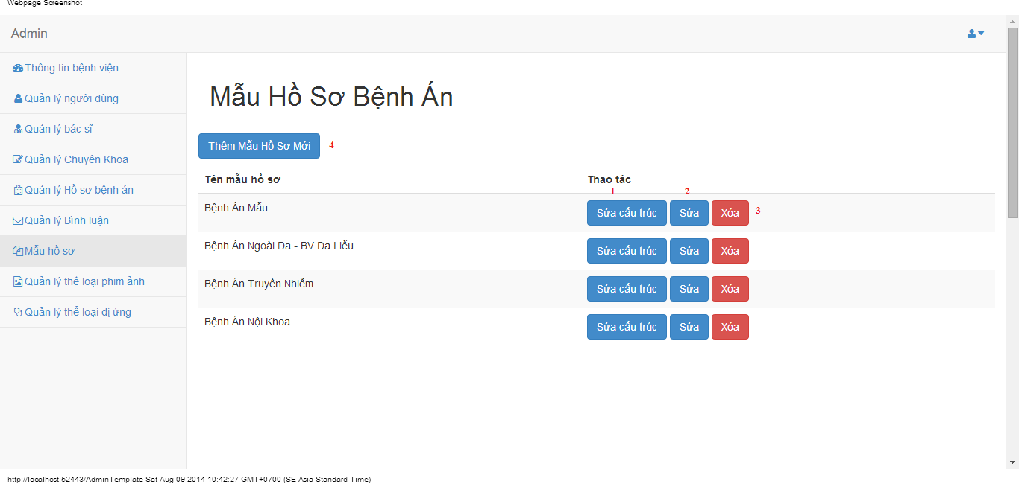

#### Objects and Actions

#### Data fields

|  |  |  |  |  |  |  |
| --- | --- | --- | --- | --- | --- | --- |
| **Field No** | **Field name** | **Type** | **Mandatory** | **Data type** | **Max length** | **Description** |

#### Actions

|  |  |  |  |  |  |
| --- | --- | --- | --- | --- | --- |
| **Field No** | **Field name** | **Type** | **Action** | **Description** | **Validation** |
| 1 | Sửa cấu trúc | Button | On click | Forward to “Editor” page |  |
| 2 | Sửa | Button | On click | Forward to popup “Edit” |  |
| 3 | Xóa | Button | On click | Delete a medical profile template |  |
| 4 | Thêm mẫu hồ sơ mới | Button | On click | Forward to popup “Create” |  |

### EDIT MEDICAL PROFILE TEMPLATES SCREEN

#### Screen image

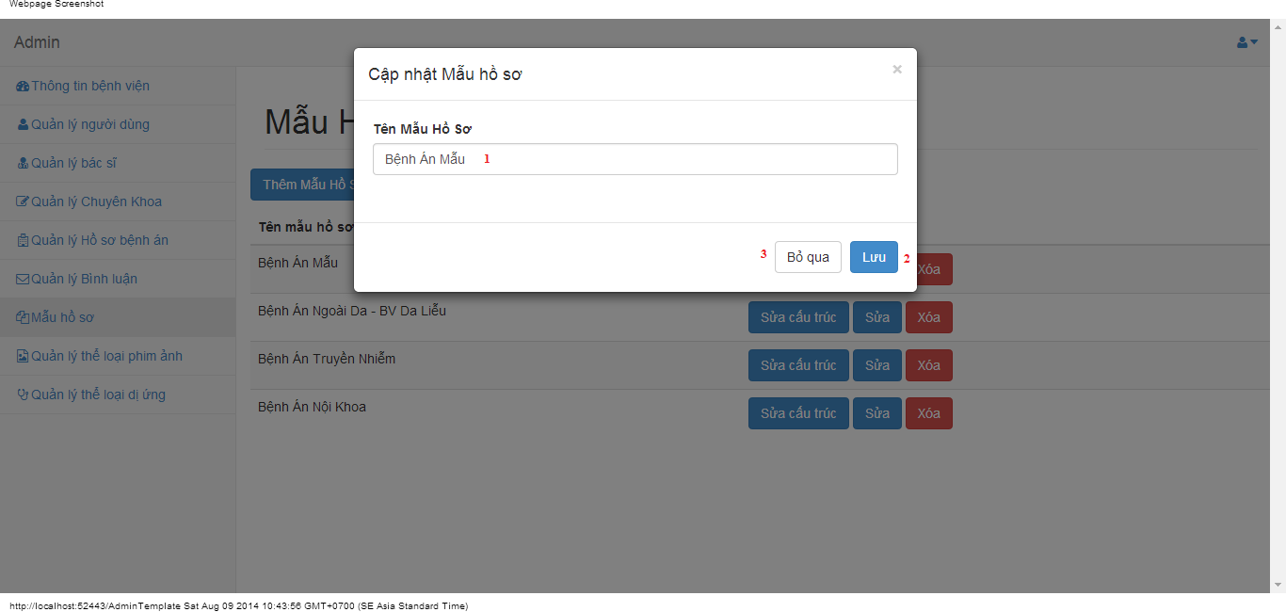

#### Objects and Actions

#### Data fields

|  |  |  |  |  |  |  |
| --- | --- | --- | --- | --- | --- | --- |
| **Field No** | **Field name** | **Type** | **Mandatory** | **Data type** | **Max length** | **Description** |
| 1 | Tên mẫu hồ sơ | Textbox | Yes | String | 50 | Contain name medical profile |

#### Actions

|  |  |  |  |  |  |
| --- | --- | --- | --- | --- | --- |
| **Field No** | **Field name** | **Type** | **Action** | **Description** | **Validation** |
| 9 | Lưu | Button | On click | Submit inputted data to server | Inputted data must be valid |
| 10 | Bỏ qua | Button | On click | Dismiss popup |  |

### ADD MEDICAL PROFILE TEMPLATES SCREEN

#### Screen image

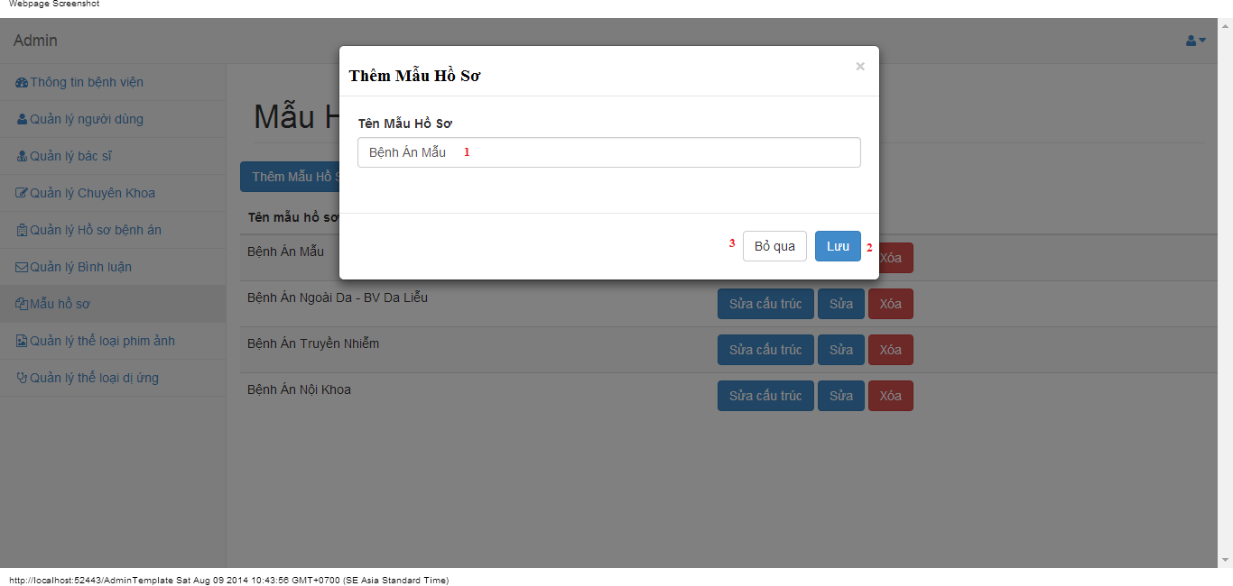

#### Objects and Actions

#### Data fields

|  |  |  |  |  |  |  |
| --- | --- | --- | --- | --- | --- | --- |
| **Field No** | **Field name** | **Type** | **Mandatory** | **Data type** | **Max length** | **Description** |
| 1 | Tên mẫu hồ sơ | Textbox | Yes | String | 50 | Contain name medical profile |

#### Actions

|  |  |  |  |  |  |
| --- | --- | --- | --- | --- | --- |
| **Field No** | **Field name** | **Type** | **Action** | **Description** | **Validation** |
| 9 | Lưu | Button | On click | Submit inputted data to server | Inputted data must be valid |
| 10 | Bỏ qua | Button | On click | Dismiss popup |  |

### EDITOR/UPDATE MEDICAL PROFILE TEMPLATES SCREEN

#### Screen image

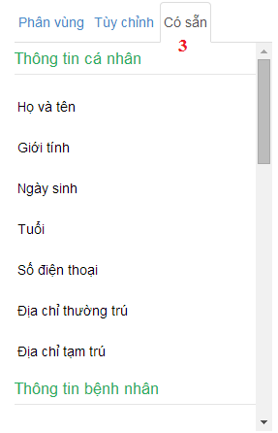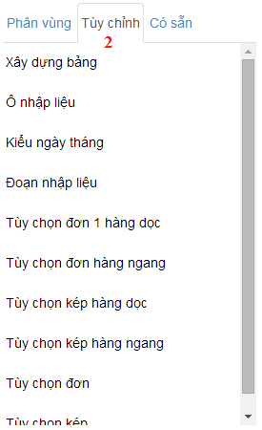 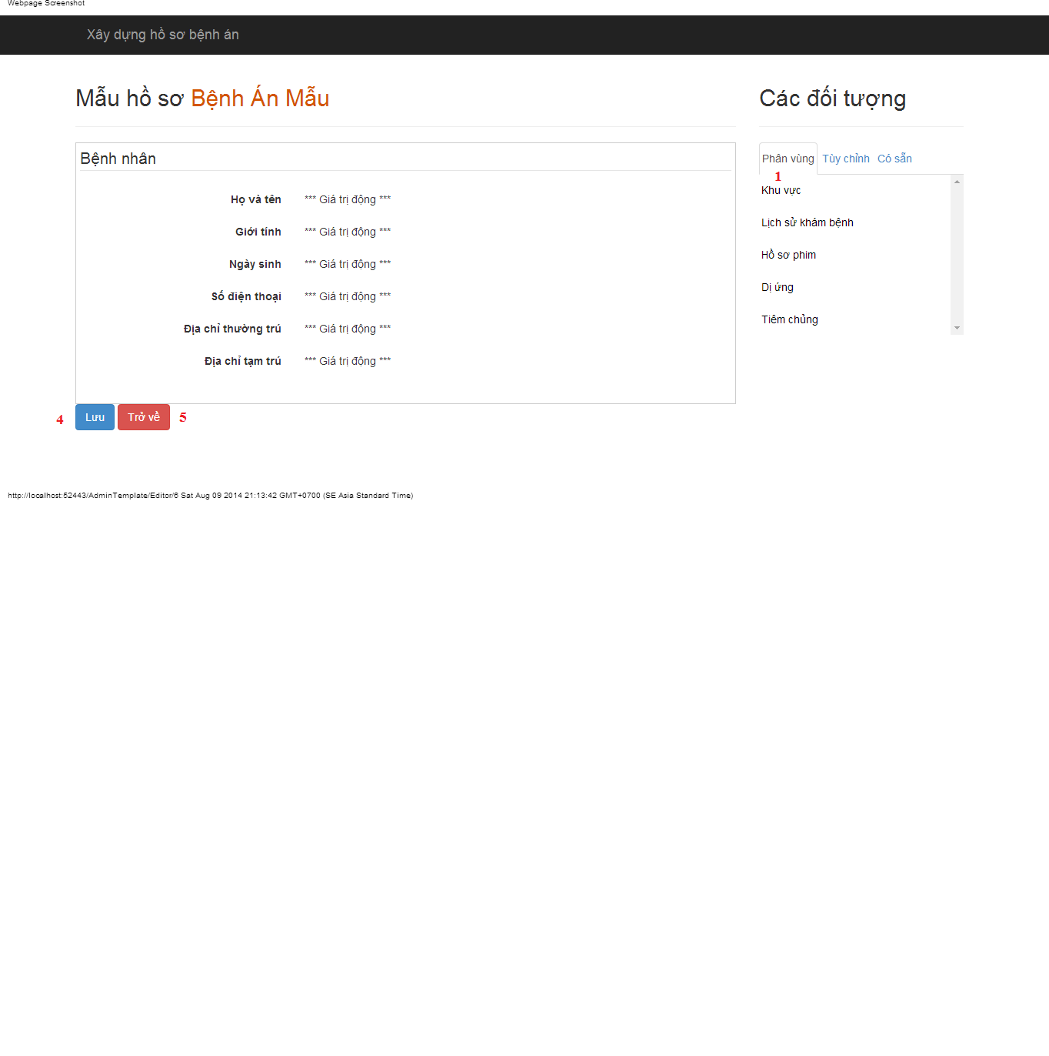

#### Objects and Actions

#### Data fields

|  |  |  |  |  |  |  |
| --- | --- | --- | --- | --- | --- | --- |
| **Field No** | **Field name** | **Type** | **Mandatory** | **Data type** | **Max length** | **Description** |

#### Actions

|  |  |  |  |  |  |
| --- | --- | --- | --- | --- | --- |
| **Field No** | **Field name** | **Type** | **Action** | **Description** | **Validation** |
| 1 | Phân vùng | Link | On click | Drag data to create/update medical profile template |  |
| 2 | Tùy chỉnh | Link | On click | Dismiss popup |  |
| 3 | Có sẵn | Link | On click | Drag data to create/update medical profile template |  |
| 4 | Lưu | Button | On click | Submit inputted data to server |  |
| 5 | Trở về | Button | On click | Back to previous page |  |

### MANAGE FILM TYPES SCREEN

#### Screen image

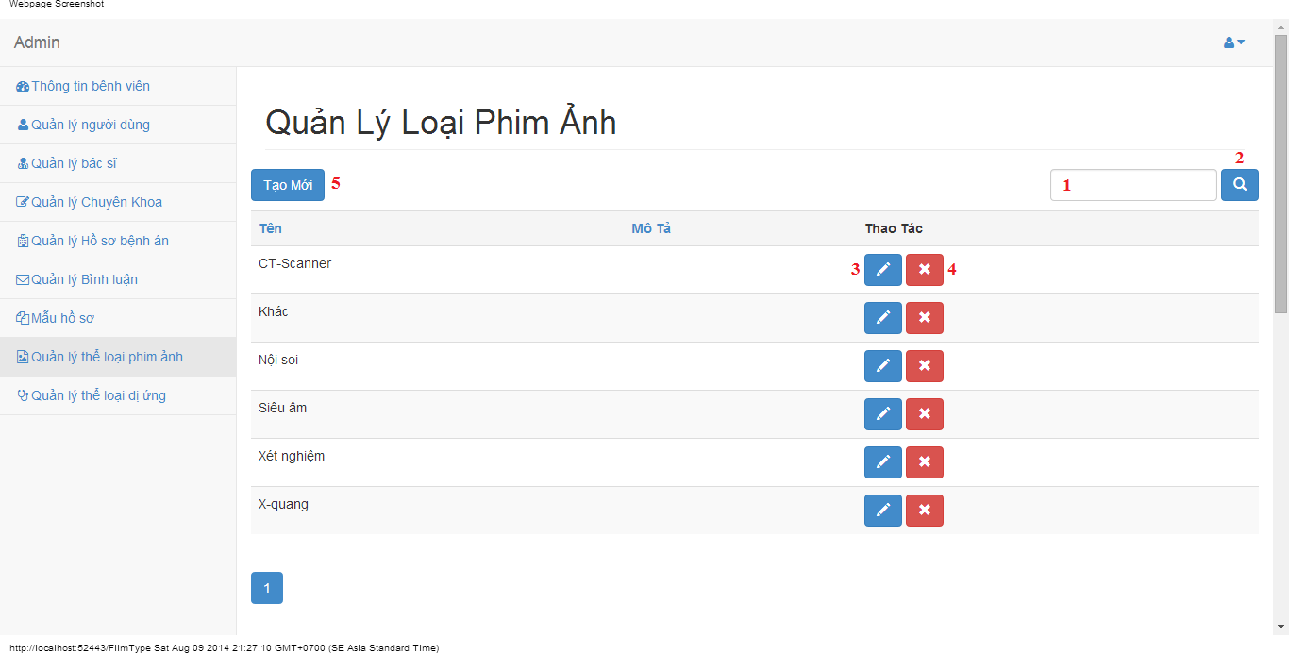

#### Objects and Actions

#### Data fields

|  |  |  |  |  |  |  |
| --- | --- | --- | --- | --- | --- | --- |
| **Field No** | **Field name** | **Type** | **Mandatory** | **Data type** | **Max length** | **Description** |
| 1 | Search | Textbox | No | String | 50 | Contain search condition to find some film type |

#### Actions

|  |  |  |  |  |  |
| --- | --- | --- | --- | --- | --- |
| **Field No** | **Field name** | **Type** | **Action** | **Description** | **Validation** |
| 2 | Tìm | Button | On click | Send inputted search condition to server |  |
| 3 | Cập nhật | Button | On click | Forward to “Edit” page |  |
| 4 | Xóa | Button | On click | Delete a film type |  |
| 5 | Tạo mới | Button | On click | Forward to “Create” page |  |

### CREATE FILM TYPE SCREEN

#### Screen image

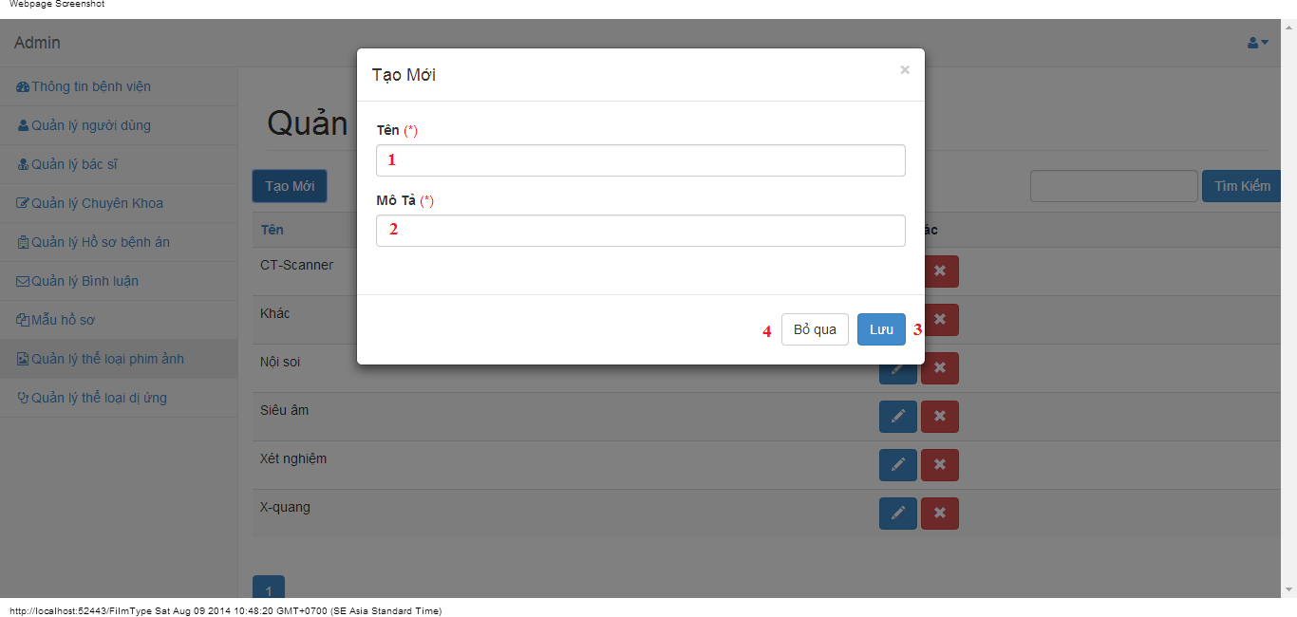

#### Objects and Actions

#### Data fields

|  |  |  |  |  |  |  |
| --- | --- | --- | --- | --- | --- | --- |
| **Field No** | **Field name** | **Type** | **Mandatory** | **Data type** | **Max length** | **Description** |
| 1 | Tên | Textbox | Yes | String | 50 | Contain film type’s name |
| 2 | Mô tả | Textbox | Yes | String | 50 | Contain film type’s description |

#### Actions

|  |  |  |  |  |  |
| --- | --- | --- | --- | --- | --- |
| **Field No** | **Field name** | **Type** | **Action** | **Description** | **Validation** |
| 9 | Lưu | Button | On click | Submit inputted data to server | Inputted data must be valid |
| 10 | Bỏ qua | Button | On click | Dismiss popup |  |

### EDIT FILM TYPE SCREEN

#### Screen image

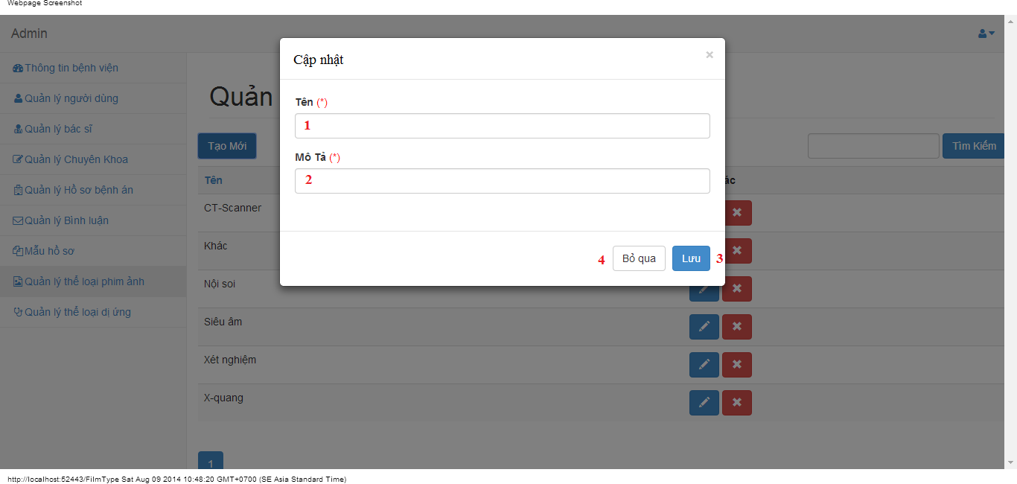

#### Objects and Actions

#### Data fields

|  |  |  |  |  |  |  |
| --- | --- | --- | --- | --- | --- | --- |
| **Field No** | **Field name** | **Type** | **Mandatory** | **Data type** | **Max length** | **Description** |
| 1 | Tên | Textbox | Yes | String | 50 | Contain film type’s name |
| 2 | Mô tả | Textbox | Yes | String | 50 | Contain film type’s description |

#### Actions

|  |  |  |  |  |  |
| --- | --- | --- | --- | --- | --- |
| **Field No** | **Field name** | **Type** | **Action** | **Description** | **Validation** |
| 9 | Lưu | Button | On click | Submit inputted data to server | Inputted data must be valid |
| 10 | Bỏ qua | Button | On click | Dismiss popup |  |

### MANAGE ALLERGY TYPES SCREEN

#### Screen image

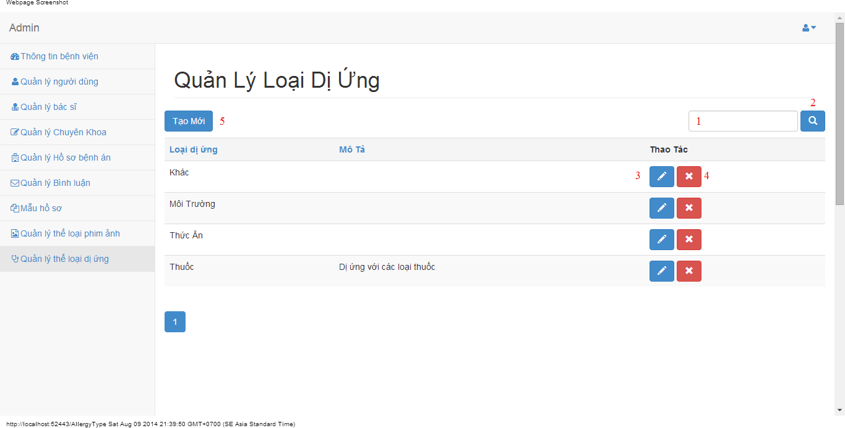

#### Objects and Actions

#### Data fields

|  |  |  |  |  |  |  |
| --- | --- | --- | --- | --- | --- | --- |
| **Field No** | **Field name** | **Type** | **Mandatory** | **Data type** | **Max length** | **Description** |
| 1 | Search | Textbox | No | String | 50 | Contain search condition to find some allergy |

#### Actions

|  |  |  |  |  |  |
| --- | --- | --- | --- | --- | --- |
| **Field No** | **Field name** | **Type** | **Action** | **Description** | **Validation** |
| 2 | Tìm | Button | On click | Send inputted search condition to server |  |
| 3 | Cập nhật | Button | On click | Forward to “Edit” page |  |
| 4 | Xóa | Button | On click | Delete an allergy type |  |
| 5 | Tạo mới | Button | On click | Forward to “Create” page |  |

### CREATE ALLERGY TYPE SCREEN

#### Screen image

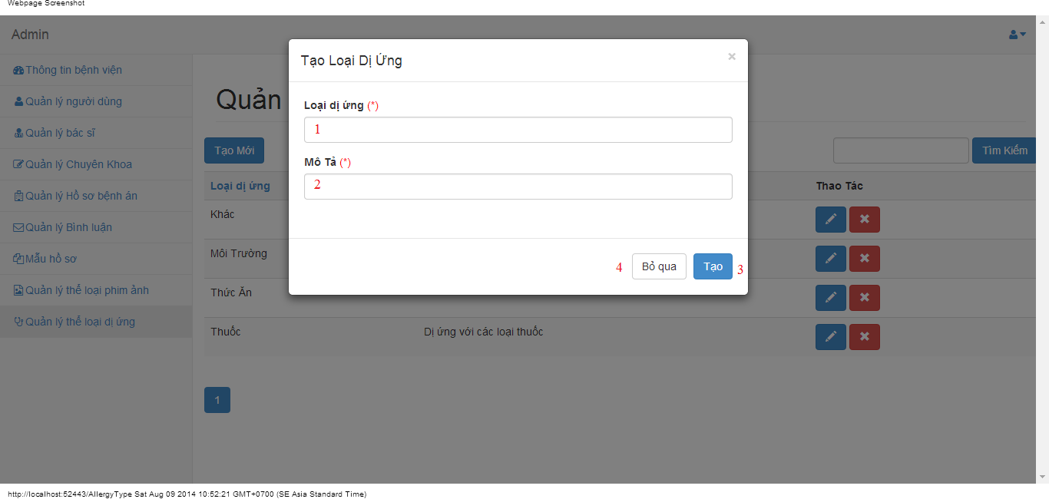

#### Objects and Actions

#### Data fields

|  |  |  |  |  |  |  |
| --- | --- | --- | --- | --- | --- | --- |
| **Field No** | **Field name** | **Type** | **Mandatory** | **Data type** | **Max length** | **Description** |
| 1 | Loại dị ứng | Textbox | Yes | String | 50 | Contain allergy type’s name |
| 2 | Mô tả | Textbox | Yes | String | 50 | Contain allergy type’s description |

#### Actions

|  |  |  |  |  |  |
| --- | --- | --- | --- | --- | --- |
| **Field No** | **Field name** | **Type** | **Action** | **Description** | **Validation** |
| 9 | Lưu | Button | On click | Submit inputted data to server | Inputted data must be valid |
| 10 | Bỏ qua | Button | On click | Dismiss popup |  |

### EDIT ALLERGY TYPE SCREEN

#### Screen image

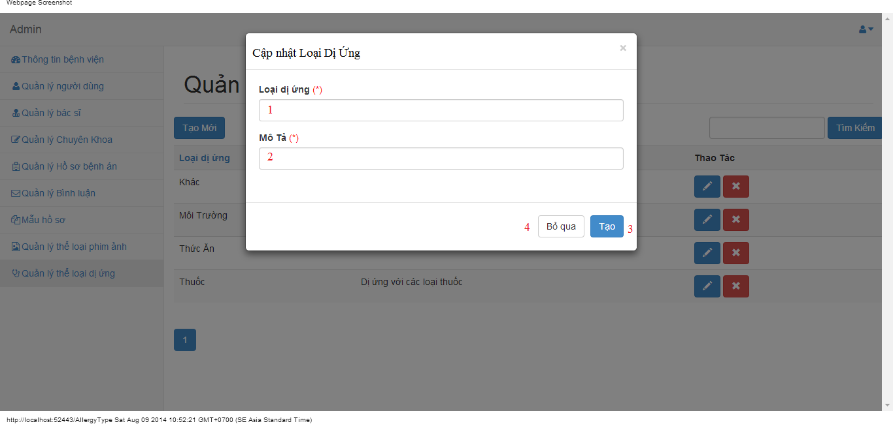

#### Objects and Actions

#### Data fields

|  |  |  |  |  |  |  |
| --- | --- | --- | --- | --- | --- | --- |
| **Field No** | **Field name** | **Type** | **Mandatory** | **Data type** | **Max length** | **Description** |
| 1 | Loại dị ứng | Textbox | Yes | String | 50 | Contain allergy type’s name |
| 2 | Mô tả | Textbox | Yes | String | 50 | Contain allergy type’s description |

#### Actions

|  |  |  |  |  |  |
| --- | --- | --- | --- | --- | --- |
| **Field No** | **Field name** | **Type** | **Action** | **Description** | **Validation** |
| 9 | Lưu | Button | On click | Submit inputted data to server | Inputted data must be valid |
| 10 | Bỏ qua | Button | On click | Dismiss popup |  |

### CHANGE PASSWORD SCREEN

#### Screen image



#### Objects and Actions

#### Data fields

|  |  |  |  |  |  |  |
| --- | --- | --- | --- | --- | --- | --- |
| **Field No** | **Field name** | **Type** | **Mandatory** | **Data type** | **Max length** | **Description** |
| 1 | Mật khẩu hiện tại | Textbox | Yes | String | 50 | Contain user’s password |
| 2 | Mật khẩu mới | Textbox | Yes | String | 50 | Contain user’s new password |
| 3 | Xác nhận mật khẩu | Textbox | Yes | String | 50 | Contain user’s re-password |

#### Actions

|  |  |  |  |  |  |
| --- | --- | --- | --- | --- | --- |
| **Field No** | **Field name** | **Type** | **Action** | **Description** | **Validation** |
| 9 | Cập nhật mật khẩu | Button | On click | Submit inputted data to server | Inputted data must be valid |
| 10 | Bỏ qua | Button | On click | Dismiss popup |  |

### MANAGE PATIENT SCREEN

#### Screen image

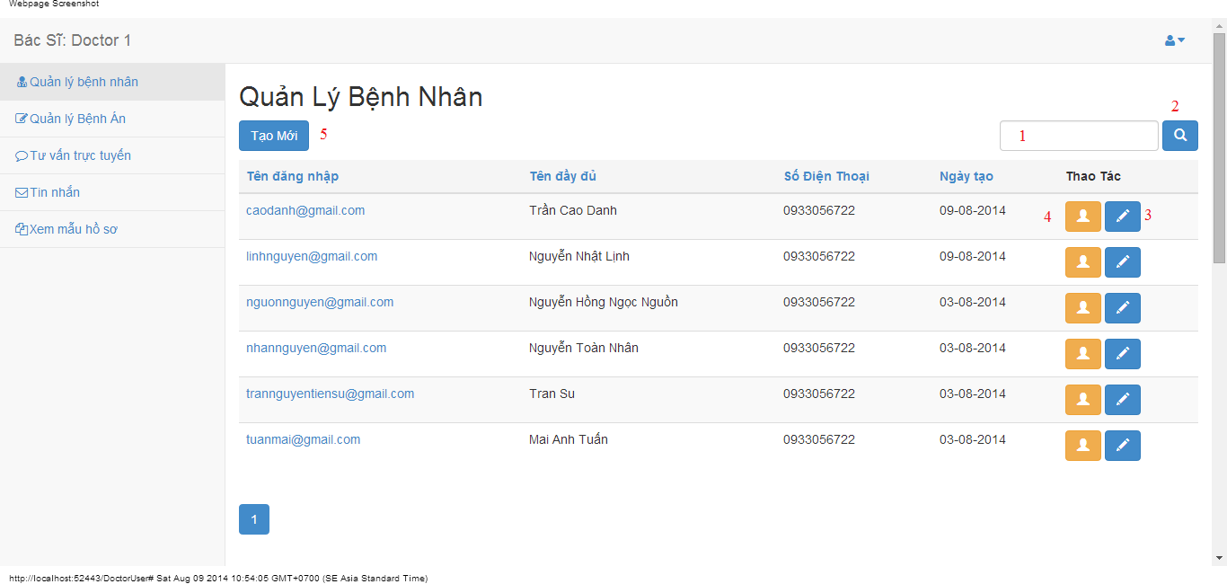

#### Objects and Actions

#### Data fields

|  |  |  |  |  |  |  |
| --- | --- | --- | --- | --- | --- | --- |
| **Field No** | **Field name** | **Type** | **Mandatory** | **Data type** | **Max length** | **Description** |
| 1 | Search | Textbox | No | String | 50 | Contain search condition to find some user account |

#### Actions

|  |  |  |  |  |  |
| --- | --- | --- | --- | --- | --- |
| **Field No** | **Field name** | **Type** | **Action** | **Description** | **Validation** |
| 2 | Tìm | Button | On click | Send inputted search condition to server |  |
| 3 | Cập nhật | Button | On click | Forward to popup “Edit” |  |
| 4 | Xem chi tiết | Link | On click | Forward to popup “View” |  |
| 5 | Tạo mới | Button | On click | Forward to popup “Create” |  |

### CREATE/EDIT PATIENT SCREEN

#### Screen image

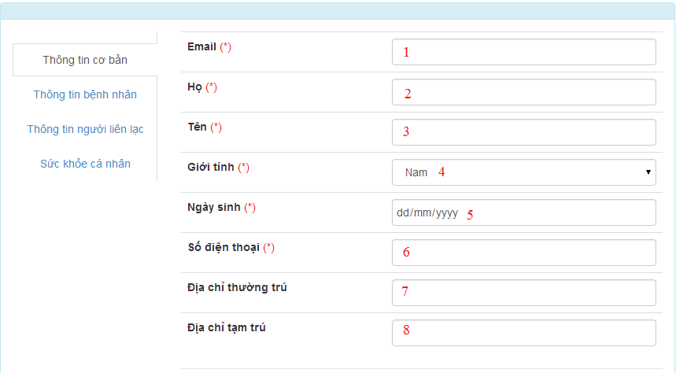









#### Objects and Actions

#### Data fields

|  |  |  |  |  |  |  |
| --- | --- | --- | --- | --- | --- | --- |
| **Field No** | **Field name** | **Type** | **Mandatory** | **Data type** | **Max length** | **Description** |
| 1 | Email | Textbox | Yes | String | 50 | Contain user’s email |
| 2 | Họ | Textbox | Yes | String | 50 | Contain user’s last name |
| 3 | Tên | Textbox | Yes | String | 50 | Contain user’s first name |
| 4 | Giới tính | Textbox | Yes | String |  | Contain user’s gender |
| 5 | Ngày sinh | Textbox | Yes | Date |  | Contain user’s birthday |
| 6 | Số điện thoại | Textbox | Yes | String | 12 | Contain user’s phone |
| 7 | Địa chỉ thường trú | Textbox | Yes | String | 50 | Contain user’s primary address |
| 8 | Địa chỉ tạm trú | Textbox | No | String | 50 | Contain user’s secondary address |
| 9 | Dân tộc | DDL | No | String | 50 | Contain user’s ethnicity |
| 10 | Quốc tịch | DDL | No | String | 50 | Contain user’s nationality |
| 11 | Công việc | Textbox | No | String | 50 | Contain user’s job |
| 12 | Nơi làm việc | Textbox | No | String | 50 | Contain user’s where to work |
| 13 | Mã số thẻ bảo hiểm y tế | Textbox | No | String | 50 | Contain user’s health insurance id |
| 14 | Ngày cấp | Textbox | No | Date | 50 | Contain user’s health insurance issued |
| 15 | Ngày hết hạn | Textbox | No | Date | 50 | Contain user’s health insurance date expired |
| 16 | Người liên lạc | Textbox | No | String | 50 | Contain user’s contact person |
| 17 | Địa chỉ người liện lạc | Textbox | No | String | 50 | Contain user’s contact person address |
| 18 | Số điện thoại người liên lạc | Textbox | No | String | 50 | Contain user’s contact person phone |
| 19 | Chiều cao | Textbox | No | String | 50 | Contain user’s height |
| 20 | Cân nặng | Textbox | No | String | 50 | Contain user’s weight |
| 21 | Màu mắt | Textbox | No | String | 50 | Contain user’s eye color |
| 22 | Màu tóc | Textbox | No | String | 50 | Contain user’s hair color |
| 23 | Nhóm máu | Textbox | No | String | 50 | Contain user’s blood type |
| 24 | Lượng đồ uống có cồn hàng tuần | Textbox | No | String | 50 | Contain user’s alcohol per week |
| 25 | Số năm uống | Textbox | No | String | 50 | Contain user’s alcohol number of year |
| 26 | Lượng thuốc hút hàng tuần | Textbox | No | String | 50 | Contain user’s smoke per week |
| 27 | Số năm hút | Textbox | No | String | 50 | Contain user’s smoke number of year |
| 28 | Tên loại thể thao | Textbox | No | String | 50 | Contain user’s sport name |
| 29 | Thời lượng tham gia hằng tuần | Textbox | No | String | 50 | Contain user’s sport per week |
| 30 | Tham gia khác | Textbox | No | String | 50 | Contain user’s exercise type |
| 31 | Thời lượng tham gia hằng tuần | Textbox | No | String | 50 | Contain user’s exercise per week |

#### Actions

|  |  |  |  |  |  |
| --- | --- | --- | --- | --- | --- |
| **Field No** | **Field name** | **Type** | **Action** | **Description** | **Validation** |
| 32 | Lưu | Button | On click | Submit inputted data to server | Inputted data must be valid |
| 33 | Bỏ qua | Button | On click | Dismiss model |  |

### VIEW PATIENT SCREEN

#### Screen image

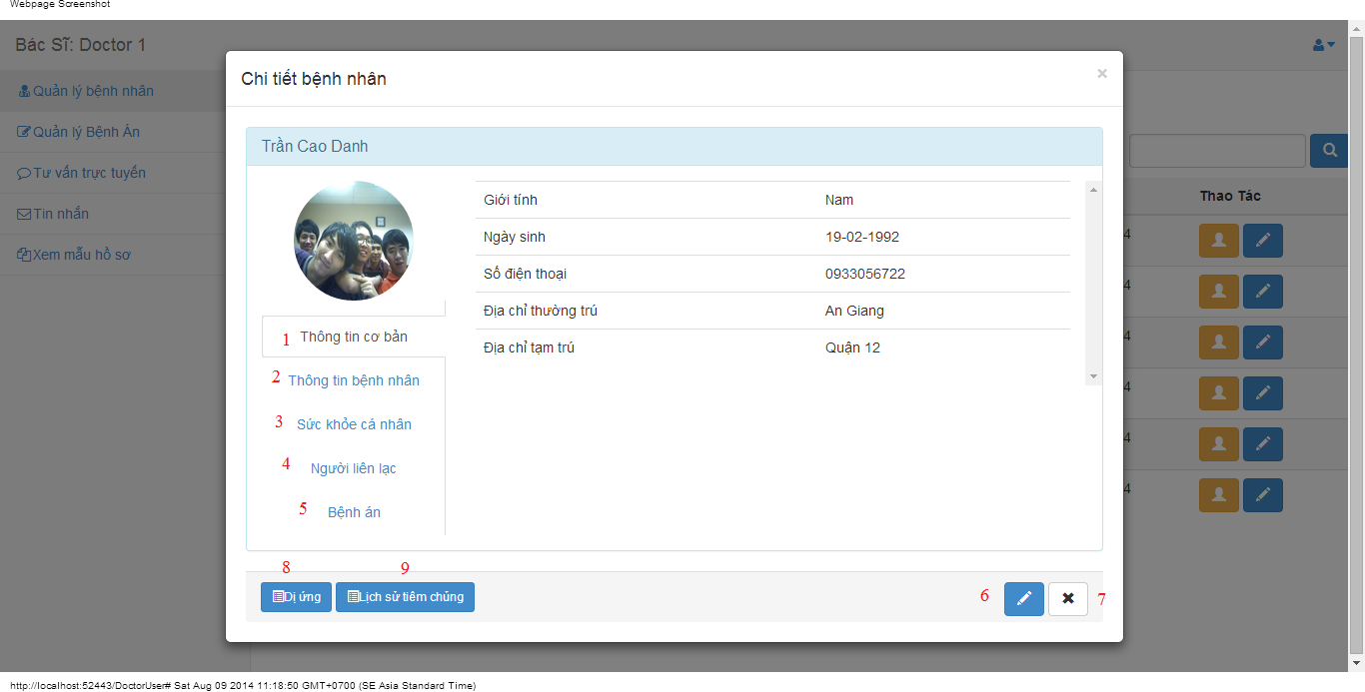

#### Objects and Actions

#### Data fields

|  |  |  |  |  |  |  |
| --- | --- | --- | --- | --- | --- | --- |
| **Field No** | **Field name** | **Type** | **Mandatory** | **Data type** | **Max length** | **Description** |

#### Actions

|  |  |  |  |  |  |
| --- | --- | --- | --- | --- | --- |
| **Field No** | **Field name** | **Type** | **Action** | **Description** | **Validation** |
| 1 | Thông tin cơ bản | Link | On click | Contain user’s basic information. |  |
| 2 | Thông tin bệnh nhân | Link | On click | Contain patient’s information. |  |
| 3 | Sức khỏe cá nhân | Link | On click | Contain user’s health record |  |
| 4 | Người liên lạc | Link | On click | Contain user’s contact person information |  |
| 5 | Bệnh án | Link | On click | Add/Edit medical profile for patient |  |
| 6 | Cập nhật | Button | On click | Forward to popup “EditPatient” |  |
| 7 | Bỏ qua | Button | On click | Dismiss modal |  |
| 8 | Dị ứng | Button | On click | Forward to popup “Allergy” |  |
| 9 | Lịch sử tiêm chủng | Button | On click | Forward to popup “Immunization” |  |

### DOCTOR COMMENT SCREEN

#### Screen image

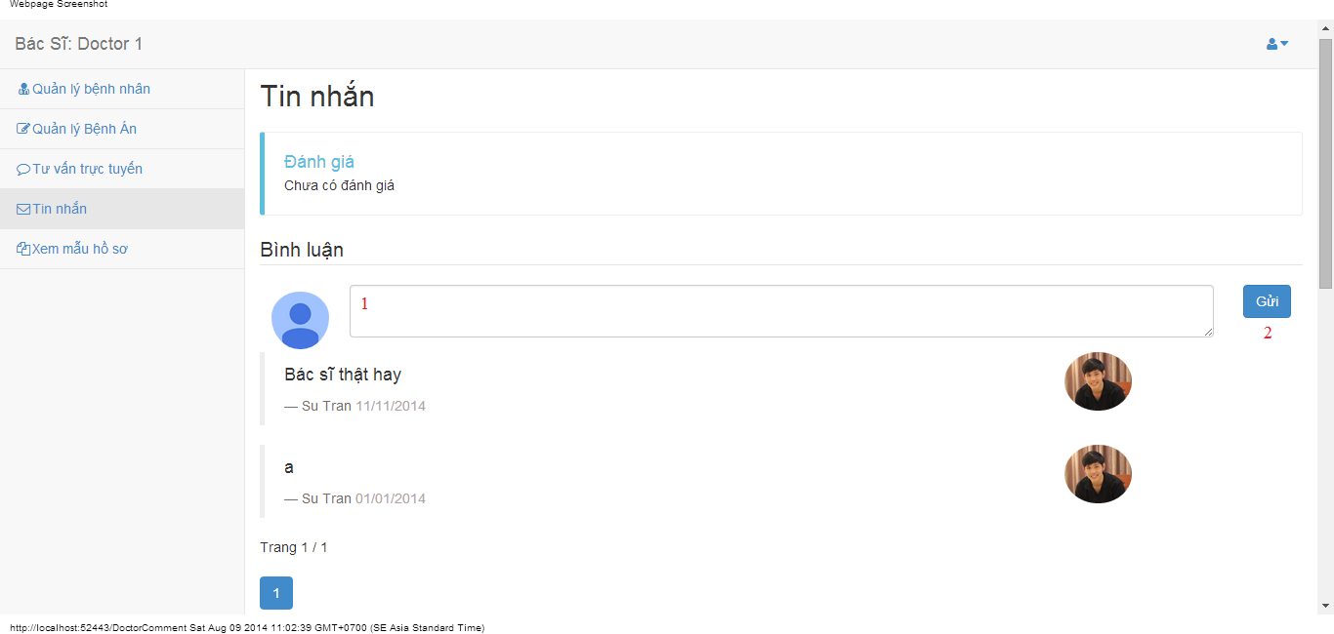

#### Objects and Actions

#### Data fields

|  |  |  |  |  |  |  |
| --- | --- | --- | --- | --- | --- | --- |
| **Field No** | **Field name** | **Type** | **Mandatory** | **Data type** | **Max length** | **Description** |
| 1 | Bình luận | Textbox | No | String |  | Comment of doctor |

#### Actions

|  |  |  |  |  |  |
| --- | --- | --- | --- | --- | --- |
| **Field No** | **Field name** | **Type** | **Action** | **Description** | **Validation** |
| 2 | Gửi | Button | On click | Summit inputted data to server |  |

### DOCTOR CONVERSATION SCREEN

#### Screen image

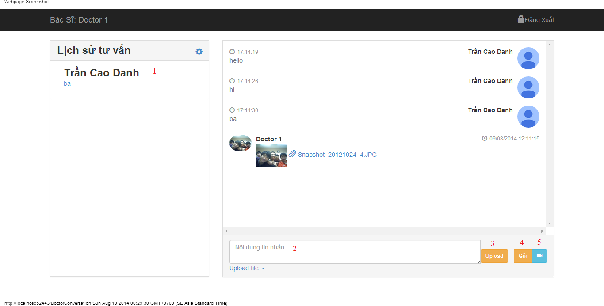

#### Objects and Actions

#### Data fields

|  |  |  |  |  |  |  |
| --- | --- | --- | --- | --- | --- | --- |
| **Field No** | **Field name** | **Type** | **Mandatory** | **Data type** | **Max length** | **Description** |
| 2 | Nội dung tin nhắn | Textbox | No | String |  | Contain user’s content conversation |

#### Actions

|  |  |  |  |  |  |
| --- | --- | --- | --- | --- | --- |
| **Field No** | **Field name** | **Type** | **Action** | **Description** | **Validation** |
| 1 | Lịch sử tư vấn | Link | On click | Click on a patient to chat |  |
| 3 | Upload | File | On click | Submit inputted file to server |  |
| 4 | Gửi | Button | On click | Submit inputted data to server |  |
| 5 | Yêu cầu xem webcam | Button | On click | Request webcam to patient |  |

### DOCTOR INFORMATION SCREEN

#### Screen image

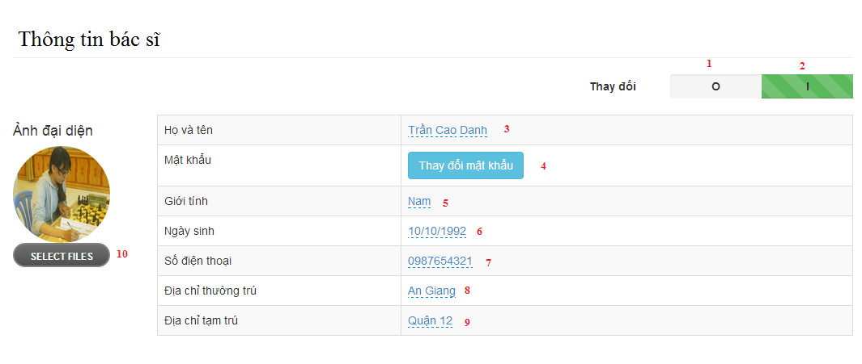

#### Objects and Actions

#### Data fields

|  |  |  |  |  |  |  |
| --- | --- | --- | --- | --- | --- | --- |
| **Field No** | **Field name** | **Type** | **Mandatory** | **Data type** | **Max length** | **Description** |
| 3 | Họ và tên | Textbox | Yes | String | 50 | Contain user’s full name |
| 5 | Giới tính | List | Yes | String | 50 | Contain user’s gender |
| 6 | Ngày sinh | Textbox | Yes | Date | 12 | Contain user’s birthday |
| 7 | Số điện thoại | Textbox | Yes | String | 12 | Contain user’s phone |
| 8 | Địa chỉ thường trú | Textbox | Yes | String | 50 | Contain user’s primary address |
| 9 | Địa chỉ tạm trú | Textbox | No | String | 50 | Contain user’s secondary address |

#### Actions

|  |  |  |  |  |  |
| --- | --- | --- | --- | --- | --- |
| **Field No** | **Field name** | **Type** | **Action** | **Description** | **Validation** |
| 1 | 0 | Checkbox | On click | Click “0” to view table admin information |  |
| 2 | I | Checkbox | On click | Click “I” to edit table data admin information |  |
| 4 | Thay đổi mật khẩu | Button | On click | Forward to popup “ChangePassword” |  |
| 10 | Chọn tệp | File | On click | Submit inputted file to server |  |

### PATIENT INFORMATION SCREEN

#### Screen image

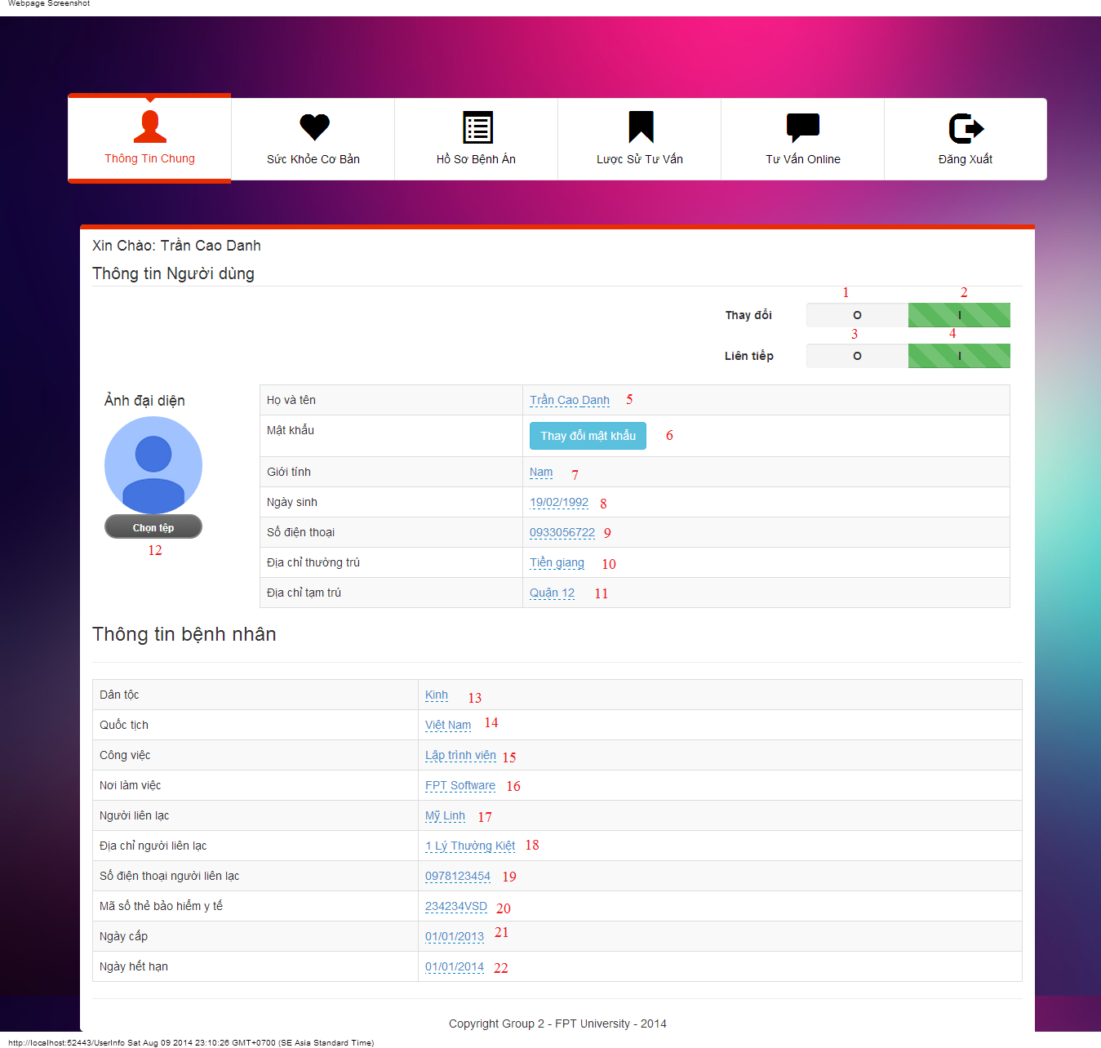

#### Objects and Actions

#### Data fields

|  |  |  |  |  |  |  |
| --- | --- | --- | --- | --- | --- | --- |
| **Field No** | **Field name** | **Type** | **Mandatory** | **Data type** | **Max length** | **Description** |
| 5 | Họ Tên | Textbox | Yes | String | 50 | Contain user’s full name |
| 7 | Giới tính | Textbox | Yes | String |  | Contain user’s gender |
| 8 | Ngày sinh | Textbox | Yes | Date |  | Contain user’s birthday |
| 9 | Số điện thoại | Textbox | Yes | String | 12 | Contain user’s phone |
| 10 | Địa chỉ thường trú | Textbox | Yes | String | 50 | Contain user’s primary address |
| 11 | Địa chỉ tạm trú | Textbox | No | String | 50 | Contain user’s secondary address |
| 12 | Dân tộc | DDL | No | String | 50 | Contain user’s ethnicity |
| 13 | Quốc tịch | DDL | No | String | 50 | Contain user’s nationality |
| 14 | Công việc | Textbox | No | String | 50 | Contain user’s job |
| 15 | Nơi làm việc | Textbox | No | String | 50 | Contain user’s where to work |
| 20 | Mã số thẻ bảo hiểm y tế | Textbox | No | String | 50 | Contain user’s health insurance id |
| 21 | Ngày cấp | Textbox | No | Date | 50 | Contain user’s health insurance issued |
| 22 | Ngày hết hạn | Textbox | No | Date | 50 | Contain user’s health insurance date expired |
| 18 | Người liên lạc | Textbox | No | String | 50 | Contain user’s contact person |
| 19 | Địa chỉ người liện lạc | Textbox | No | String | 50 | Contain user’s contact person address |
| 20 | Số điện thoại người liên lạc | Textbox | No | String | 50 | Contain user’s contact person phone |

#### Actions

|  |  |  |  |  |  |
| --- | --- | --- | --- | --- | --- |
| **Field No** | **Field name** | **Type** | **Action** | **Description** | **Validation** |
| 1 | 0 | Checkbox | On click | Click “0” to view table admin information |  |
| 2 | I | Checkbox | On click | Click “I” to edit table data admin information |  |
| 3 | O | Checkbox | On click | Click “0” to not next value after 300 second |  |
| 4 | I | Checkbox | On click | Click “0” to next value after 300 second |  |
| 6 | Thay đổi mật khẩu | Button | On click | Forward to popup “ChangePassword” |  |
| 12 | Chọn tệp | File | On click | Submit inputted file to server |  |

### PATIENT HEALTH RECORD SCREEN

#### Screen image

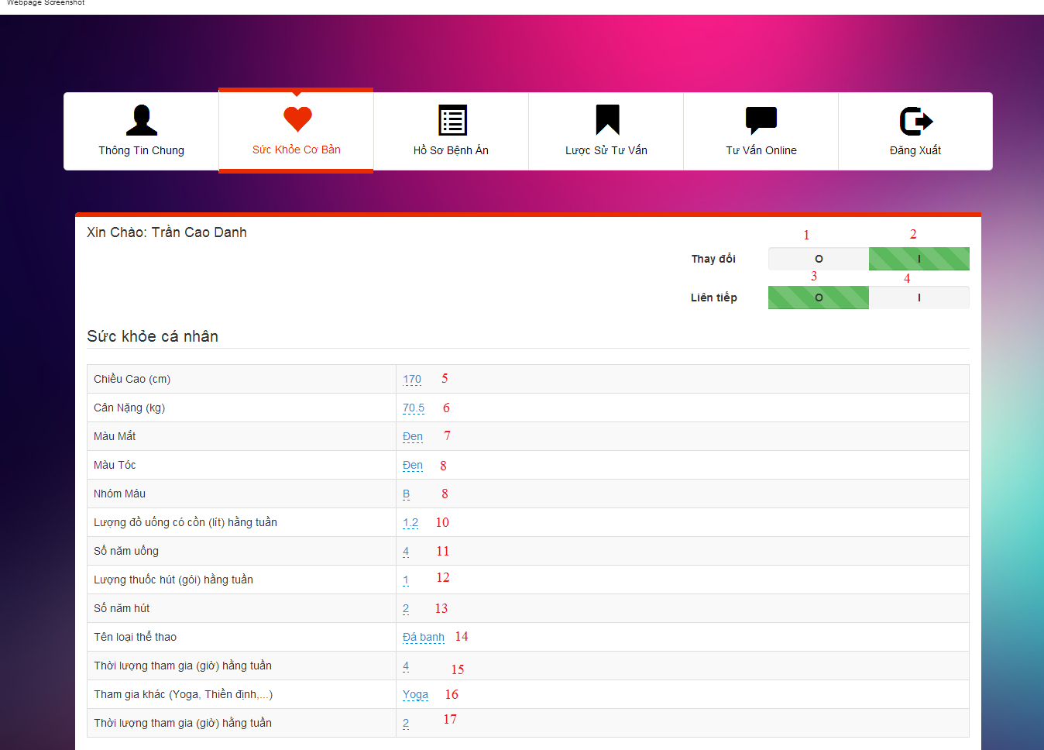

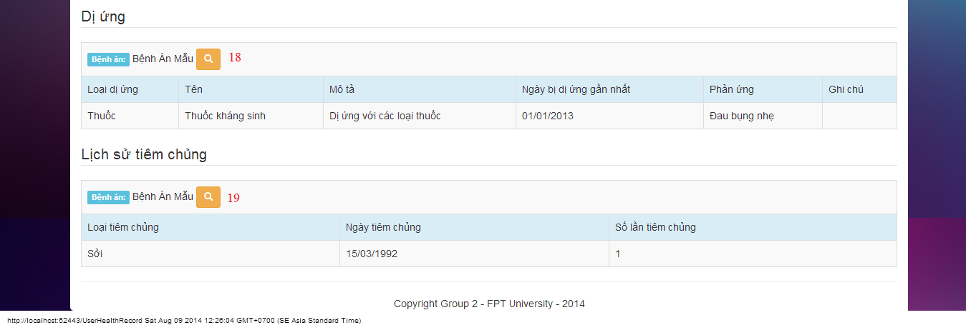

#### Objects and Actions

#### Data fields

|  |  |  |  |  |  |  |
| --- | --- | --- | --- | --- | --- | --- |
| **Field No** | **Field name** | **Type** | **Mandatory** | **Data type** | **Max length** | **Description** |
| 5 | Chiều cao | Textbox | No | String | 50 | Contain user’s height |
| 6 | Cân nặng | Textbox | No | String | 50 | Contain user’s weight |
| 7 | Màu mắt | Textbox | No | String | 50 | Contain user’s eye color |
| 8 | Màu tóc | Textbox | No | String | 50 | Contain user’s hair color |
| 9 | Nhóm máu | Textbox | No | String | 50 | Contain user’s blood type |
| 10 | Lượng đồ uống có cồn hàng tuần | Textbox | No | String | 50 | Contain user’s alcohol per week |
| 11 | Số năm uống | Textbox | No | String | 50 | Contain user’s alcohol number of year |
| 12 | Lượng thuốc hút hàng tuần | Textbox | No | String | 50 | Contain user’s smoke per week |
| 13 | Số năm hút | Textbox | No | String | 50 | Contain user’s smoke number of year |
| 14 | Tên loại thể thao | Textbox | No | String | 50 | Contain user’s sport name |
| 15 | Thời lượng tham gia hằng tuần | Textbox | No | String | 50 | Contain user’s sport per week |
| 16 | Tham gia khác | Textbox | No | String | 50 | Contain user’s exercise type |
| 17 | Thời lượng tham gia hằng tuần | Textbox | No | String | 50 | Contain user’s exercise per week |

#### Actions

|  |  |  |  |  |  |
| --- | --- | --- | --- | --- | --- |
| **Field No** | **Field name** | **Type** | **Action** | **Description** | **Validation** |
| 1 | 0 | Checkbox | On click | Click “0” to view table admin information |  |
| 2 | I | Checkbox | On click | Click “I” to edit table data admin information |  |
| 3 | O | Checkbox | On click | Click “0” to not next value after 300 second |  |
| 4 | I | Checkbox | On click | Click “0” to next value after 300 second |  |
| 18 | Bệnh án mẫu | Button | On click | Forward to “Details” medical profile page |  |
| 19 | Bệnh án mẫu | Button | On click | Forward to “Details” medical profile page |  |

### MEDICAL PROFILE SCREEN

#### Screen image

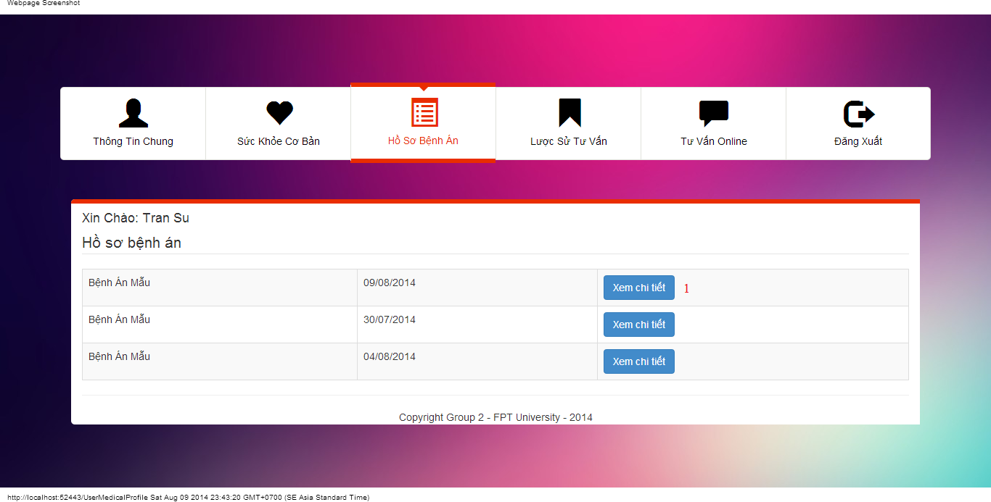

#### Objects and Actions

#### Data fields

|  |  |  |  |  |  |  |
| --- | --- | --- | --- | --- | --- | --- |
| **Field No** | **Field name** | **Type** | **Mandatory** | **Data type** | **Max length** | **Description** |

#### Actions

|  |  |  |  |  |  |
| --- | --- | --- | --- | --- | --- |
| **Field No** | **Field name** | **Type** | **Action** | **Description** | **Validation** |
| 1 | Xem chi tiết | Button | On click | Forward to “Details” medical profile page |  |

### VIEW CONSULT HISTORY SCREEN

#### Screen image

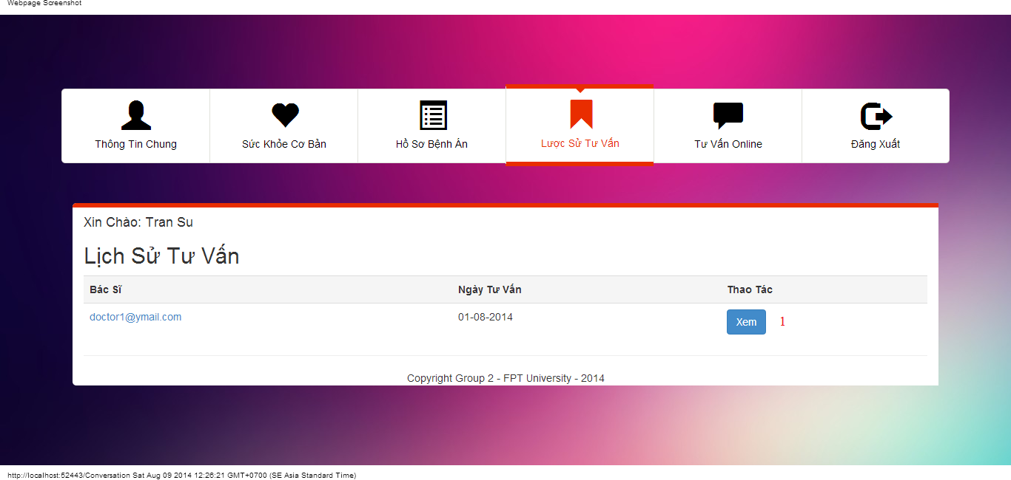

#### Objects and Actions

#### Data fields

|  |  |  |  |  |  |  |
| --- | --- | --- | --- | --- | --- | --- |
| **Field No** | **Field name** | **Type** | **Mandatory** | **Data type** | **Max length** | **Description** |

#### Actions

|  |  |  |  |  |  |
| --- | --- | --- | --- | --- | --- |
| **Field No** | **Field name** | **Type** | **Action** | **Description** | **Validation** |
| 1 | Xem | Button | On click | Forward to “ConversationDetails” page |  |

### USER CONVERSATION SCREEN

#### Screen image

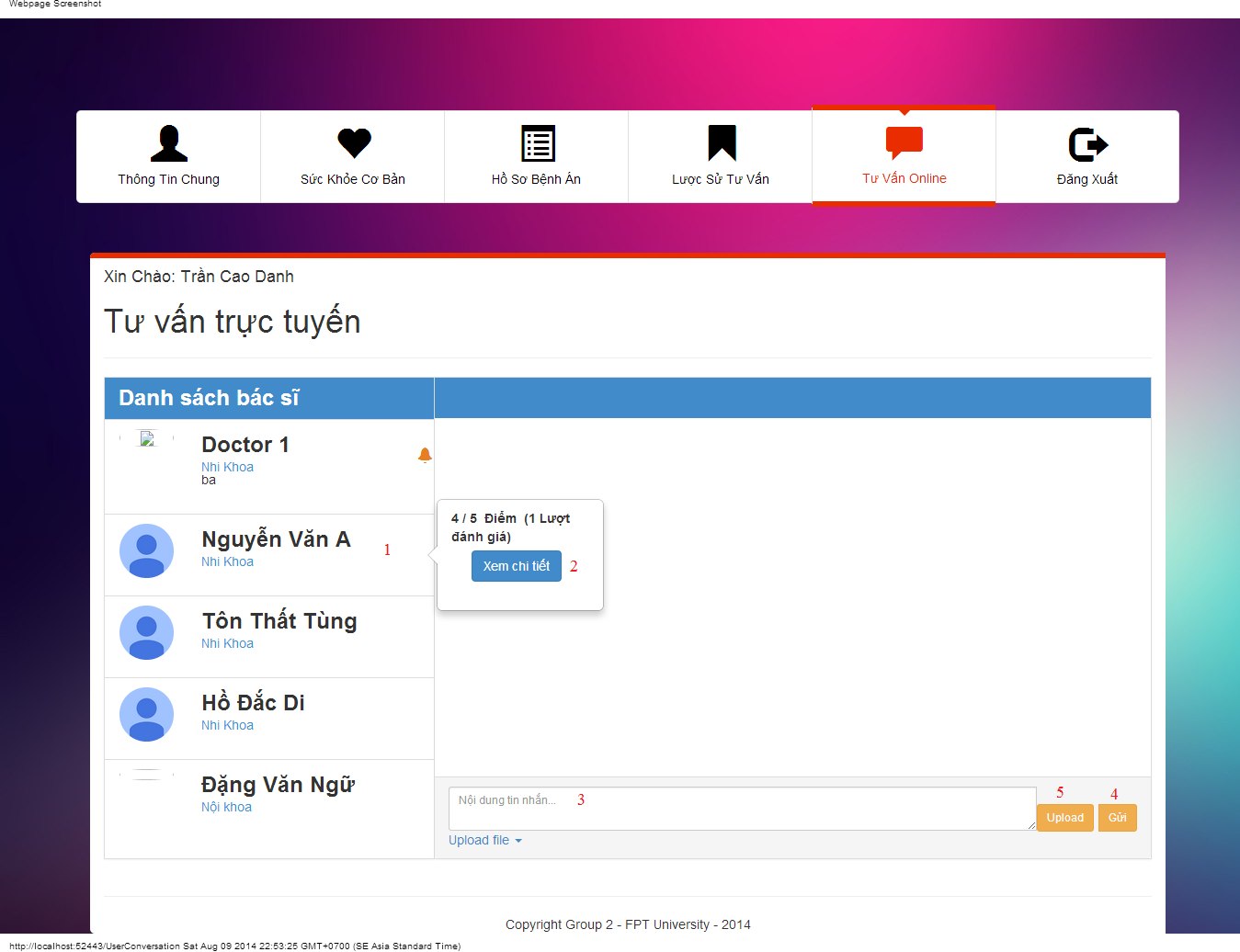

#### Objects and Actions

#### Data fields

|  |  |  |  |  |  |  |
| --- | --- | --- | --- | --- | --- | --- |
| **Field No** | **Field name** | **Type** | **Mandatory** | **Data type** | **Max length** | **Description** |
| 3 | Nội dung tin nhắn | Textbox | No | String |  | Contain user’s content conversation |

#### Actions

|  |  |  |  |  |  |
| --- | --- | --- | --- | --- | --- |
| **Field No** | **Field name** | **Type** | **Action** | **Description** | **Validation** |
| 1 | Danh sách bác sĩ | Link | On click | Click on a doctor to chat |  |
| 2 | Xem chi tiết | Button | On click | Forward to “Comment” page |  |
| 4 | Gửi | Button | On click | Submit inputted data to server |  |
| 5 | Upload | File | On click | Submit inputted file to server |  |

### USER COMMENT/RATING SCREEN

#### Screen image

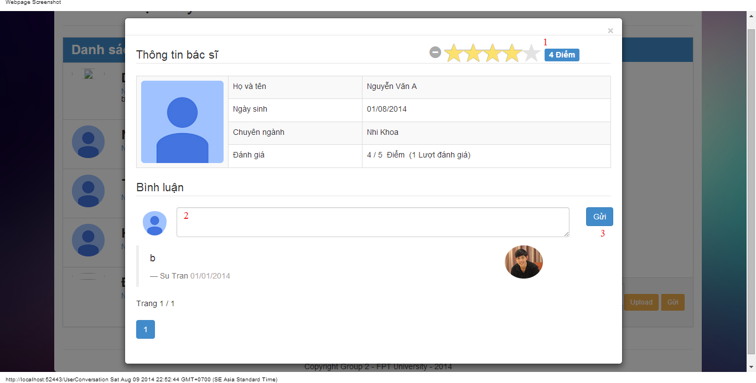

#### Objects and Actions

#### Data fields

|  |  |  |  |  |  |  |
| --- | --- | --- | --- | --- | --- | --- |
| **Field No** | **Field name** | **Type** | **Mandatory** | **Data type** | **Max length** | **Description** |
| 2 | Bình luận | Textbox | No | String |  | Comment of user |

#### Actions

|  |  |  |  |  |  |
| --- | --- | --- | --- | --- | --- |
| **Field No** | **Field name** | **Type** | **Action** | **Description** | **Validation** |
| 1 | Điểm | Button | On click | Summit inputted rate to server |  |
| 3 | Gửi | Button | On click | Summit inputted data to server |  |

## Database Design

